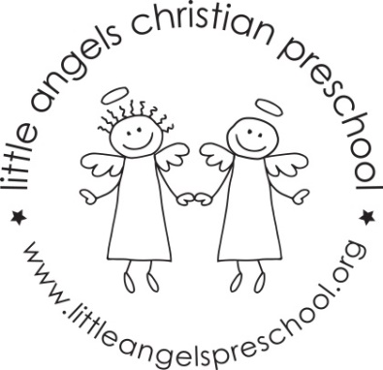

Newsletter January 2019
Dear Parents,
Welcome back and Happy New Year, we hope you had a blessed and wonderful Christmas. Thank you all so much for the generous gifts, we really appreciate them.
We have planned some new and exciting activities for January. Our themes will be winter with snow and penguins, zoo and shapes.
Our art activities will include painting with brushes, using glue sticks to make a collage and painting with frozen paints. We will build with a variety of different blocks and have frozen water, snow, and sand in our sensory table. To develop our fine motor skills we will work with play dough, manipulative toys and puzzles.
Our dramatic play area will include a doctor’s office, housekeeping and a pizza parlor.
Mrs Oehler our school music teacher will visit us once a week beginning in January for our music class, we are very excited about this! Father Jesse will continue to visit each month for our Chapel time. The children really enjoy his visits.
Reminder, please put hats, gloves etc. into the sleeve of your child’s coat. Thanks!
Reminder: No school Monday Jan 21st – Martin Luther King Day

Martha Carroll and Maggie Killick

