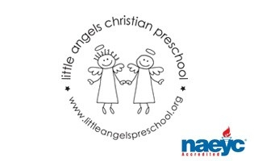

December 2018

Toddler Newsletter – Loppnow/Schaefer/Katzbeck

December will be a fun month as we explore all things Christmas and also transportation. The room is getting full of Christmas spirit with decorations including a tree that the toddlers will help decorate. We’re planning lots of fun activities and toys that involve cars, trains, planes, construction vehicles, trucks and boats. We will explore the reason for the season as well with nativity scene toys, stories and songs. The toddlers will also be working on special gifts for Christmas, art and letters to Santa.

Reminders:
• Please be sure to dress your child for the fluctuating weather – we love to go outside and want the children to be comfortable.

• Class Christmas Parties December 17 and 18 at 11:10.
Room parents will contact parents with further details

• No school December 24-January7. Classes resume January 8

We wish you a happy and healthy holiday season. Thank you for sharing your children with us. They are such a joy and blessing!

Your Toddler Teachers,

Mrs. Laura Loppnow, Mrs. Schaefer and Mrs. Katzbeck

