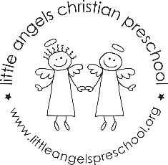 DECEMBER 2’s NEWSLETTER

This month in the 2’s we are celebrating the Christmas season. We will be doing process art projects, sensory exploration and many new challenging table games. The dramatic play area will be a holiday house and Santa’s workshop. At group time we will sing Christmas songs, use instruments and introduce new flannel board stories. Look for emails from the room parents regarding our holiday party. It is a short month but we will be making good use of our time in the classroom! We hope everyone has a very Merry Christmas and a Happy New Year!
Martha Carroll and Maggie Killick

