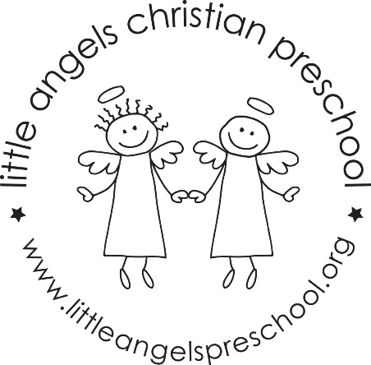
November 2018, Three’s Newsletter

We can hardly believe it’s already November! The children have formed wonderful friendships and are becoming more independent every day! Thank you to everyone that came to conferences.

Our themes this month are: land transportation, Thanksgiving and construction. We will also be adding our writing table this month! We will encourage all children to take part in this. We will also continue our weekly chapel and music class.

For large motor, we will try to go outside as weather permits. Please remember hats and mittens as weather grows colder.

We will talk a lot about Thanksgiving and what the children are thankful for. Reminder we will be closed November 21-23 for the holiday.

As usual, we are always available if you have any questions!
Anne & Sue

