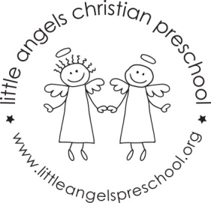
November newsletter
Dear Parents,
The children have settled well into our classroom and we are really enjoying getting to know them. We had lots of fun at our first party this week, thank you for making them so enjoyable for the children.
For the month of November our themes will be different types of transportation and Thanksgiving. We will have feathers, water and cotton balls in the sensory table and for art we will be making some traffic lights, painting with feathers and kitchen utensils and decorating a train shape.
During the first week of November we will have a school bus visiting for the children to explore while parked outside. This will be on Monday the 5th and Tuesday the 6th of November.
We will be singing “My Little Turkey”, “This Little Train” and “The Wheels on the Bus” as well as learning some new flannel board stories and reading some books including “I’m Your Bus” and “ Biscuits Thanksgiving ”. We will be having a special all school Thanksgiving snack on Monday and Tuesday November 19th and 20th. This is always a fun event.
Reminder: There is no school Friday November 2nd – In Service day.
Thanksgiving break is November 21st – 23rd.
As the weather gets colder we will continue to go outside unless it is raining or too cold, please make sure your child’s outdoor coat is labeled with their name. Please put hats, gloves etc. into the sleeve of the coat. We are not able to look in each child’s backpack for these. Thanks!
God bless you and your family and have a blessed Thanksgiving.
Martha Carroll and Maggie Killick

