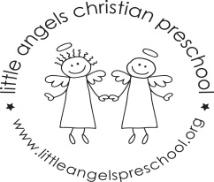
September 2018 2’s Newsletter

Dear Parents
Welcome to our Little Angels two-year-old program, we are very excited to start the new school year and especially excited about getting to know the children and their different personalities
During the month of September the children will be exploring the classroom and playground as they adjust to separating from their care givers and make new friends. Our themes will be “Welcome to preschool”, “Getting to know you” “Friends” and “Families”. we will be doing some fun projects including art, play dough, finger plays and reading many favorite stories.
To help the children transition into the classroom, please bring in a family photograph which we will display for the children to look at, thank you!
We hope you all will be able to attend the ice cream social on Thursday September 13th from 5.30 – 6.30pm; it is always lots of fun.
School photo days will be during the week of Sept 24th more details to follow!
Please make sure that your child has diapers (if needed) and a change of clothes in their backpack in case of accidents. Also, please label all clothes, jackets, coats etc. with your child’s name.
We look forward to a terrific year and getting to know all of you. If you have any questions or concerns, please don’t hesitate to get in contact with us.
God bless you and your family,
Martha Carroll and Maggie Killick

