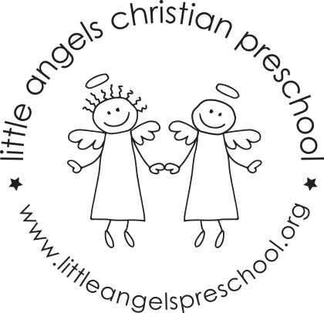

May 2018 Newsletter
Wow, this school year has just whizzed by. It’s hard to believe that it is May already! The weather has improved and we are enjoying playing outside on the playground.
It has been a great year, getting to know all of the children and watching them become so comfortable in our class.
During May, our themes will be fruit and veggies, mothers and families and of course we will end the year with kid’s choice and crazy days! We will have some Christmas and other holiday themed table toys and we will sing “The Pumpkin on the Vine” and some other favorite songs and stories the children have especially enjoyed this year. In the sensory table we will have soapy water, fake grass with animals and sand.
For art we will paint with fruit and veggies, use glitter paints and have free art for kid’s choice. Our dramatic play area will be a fruit and vegetable stand, pet vet and housekeeping with babies and strollers.
We will be reading “I eat Fruit”, “Is Your Mama a Llama?” along with some of the children’s favorite stories, songs and flannel boards they have enjoyed this year.
We hope you will join us for the all school picnic on Friday May 25th this is always a fun day for everyone, more information will be sent home soon.
Thank you for sharing your children with us and have a great summer.
Martha Carroll and Maggie Killick

