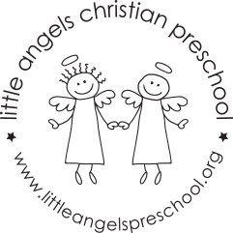
Dear families,
We do a lot singing and creative movement in our program. Singing and moving to music give the children a chance to hear and appreciate different kinds of music, express themselves through their movement, and practice new skills. The children love our daily time for singing together, and it helps them learn to cooperate in a group. Here are some of the things we do to encourage a love for music and movement.
- We listen to all different kinds of music.
- We play instruments to make our own music.
- We give the children colored scarves and paper streamers to use as they move to the music.
- We use chants to help us get through the daily routines, such as clean-up time.
- Sometimes we take a cd player outside and play music for the children to dance to and act out songs.
What you can do at home
You don’t have to play an instrument or sing on key to enjoy music with your child. Taking a few minutes to sit together and listen to music can provide a welcome break for both of you. Also, the music you share with your child doesn’t have to be “kid’s music” only. It can be reggae, country, jazz, classical, rap, or any other music you like. Here are some ideas for enjoying music and movement with your child.
- Children love a song or chant about what they are doing at the moment, especially when it use their name. While pushing your child on a swing, you might chant, “Swing high, swing low, this is the way the (your child’s name) goes.”
- Songs and fingerplays help keep children occupied at challenging times, for instance, during long car trips, while waiting in line, or when grocery shopping.
- Songs can ease your child into tasks like picking up toys, getting ready to go outside, undressing for a bath, and so on. You might try making up a chant to the tune of “Here we go ‘round the mulberry bush” such as, “water is filling up the tub, up the tub, up the tub…” or “pick up a toy and put it on the shelf, put it on the shelf…”
- Musical instruments can be made or improvised at home easily. You (or your child) already may have discovered that cooking pots and lids make wonderful instruments.
Sharing music with your child is a wonderful way to build a warm, loving relationship. It’s a gift that will last forever.
Duplicated with permission from The Creative Curriculum for Preschool.

