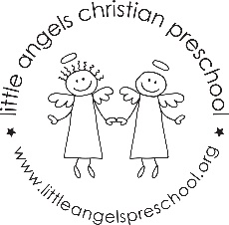
May 2018 – Three year old class

WOW! We cannot believe that this school year will be over in just a few weeks! It has been such a pleasure working with your children. They have grown in so many ways this year (and so have the teachers!) These last few weeks will be loaded with activities.
The first two weeks we will be talking about two fairy tales: The Three Little Pigs and Goldilocks and the Three Bears. We will have a “brick” house in the dramatic play area and many interesting things to build houses with in the sensory table. We will also have plenty of opportunities to talk about small, medium and large items. We will graph bears and do some patterning too!
Crazy days are crazy! The last week of school we will be doing whatever the children want to do (within reason!) We will look back at their favorite activities and do them during these last two days of school. Beach volleyball, blowing up a volcano and having a dance party are just a few of the things that we remember the children enjoying.
We will have a visit from the Spanish teacher on May 16 and 17. Senora Kimes will come into our class to give us a preview of what we have to look forward to for the next school year. We will also go into the four year old classrooms for a sneak peek of the rooms.
Please remember to mark your calendar for our all school picnic on Friday, May 25. We will provide the food so that you and your children can come and enjoy our end of the school year picnic!
Also, There is still some limited space for summer camp. Please email Sue at sdreys@stmichaelsbarrington.org for more information.
Thank you for a great year!! Sue Dreys and Anne Gierthy

