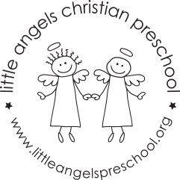
Dear families,
The hardwood unit blocks you see in our classroom are one of the most valuable learning materials we have. They come in exact sizes and shapes. For this reason when children build with blocks they learn math concepts such as the number of blocks that fill a certain space. They compare the height of their buildings and learn about geometric shapes (triangles, squares, and rectangles). When they lift, shove, stack, and move blocks, they explore weight and size. Each time they use blocks, children are making decisions about how to build a structure or solve a construction problem.
Children often use blocks to recreate the world around them – a road, a house, the zoo. They work together and learn to cooperate and make friends. We encourage children to talk about what they are doing to promote language development. We also talk with children and ask questions to expand on their block play. For example, we might say:
- I see you built a tall apartment house. How do the people get to their floor?
- Where do people park their cars when they come to visit the shopping center?
- Would you like to make a sign for your building?
These questions and comments make children more aware of what they are doing and encourage them to try out new ideas.
What you can do at home
When you take a walk in your neighborhood, point out roads and interesting buildings. You may want to purchase table blocks, colored wooden cube blocks, or cardboard brick blocks to have at home. You can also make a set out of milk cartons, which come in different sizes. Store them in shoe boxes or plastic tubs and containers and put a picture and written label on the container so your child knows where these materials belong.
Identify a place where your child can build and play with the blocks safely. Props such as clothespins, small plastic animals, and cars and trucks will extend your child’s play and inspire new ideas. The settings your child creates can be used for pretend play as well.

Duplicated with permission from The Creative Curriculum for Preschool.

