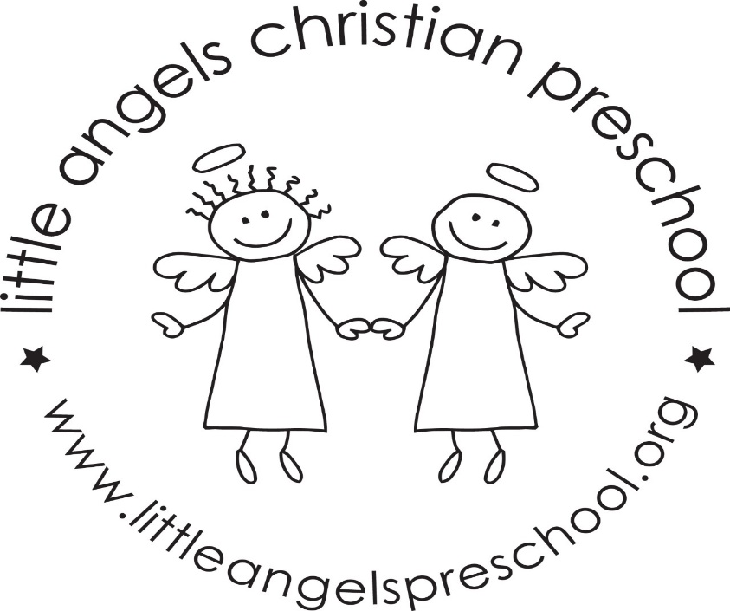
Welcome back! We hope everyone had a great spring break! We have a lot of fun things planned for the month of April.
We will continue learning about the five senses. We will learn about hearing, sight and touch this month. We will use a microscope to look at bugs, paint blindfolded, and go on nature walks to learn how we use our senses outside.
On April 13 & 14 we will celebrate meeting all of the letter people! We will have a letter people party! The classroom will have many different letter activities and puzzles. We’ll have a special snack with letters on it (cheez-its), and we will definitely dance party with the letter people. Sure to be a fun party.
The week of April 16 begins the Week of the Young Child. We will have special readers from the community every day. We will talk a lot about how special each child is. Each day will have a different theme, and Monday will be everyones favorite, Pajama Day. We will send reminders on the board daily of the next day’s theme. On Thursday April 19 from 5:30-6:30 there will be a pizza party, photo booth and special singer at the school.
On April 27 we will have our field trip to the Lincolnshire Marriott to see ‘The Emperor’s New Clothes’.
Thank you for sharing your child with us, and if you ever have any questions we are always available!
Mrs Dreys & Mrs Gierthy

