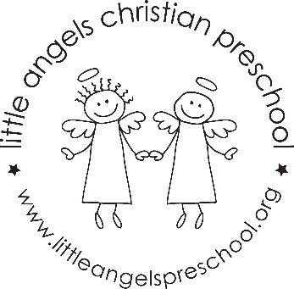2’s April Newsletter

Dear Parents,
We hope everyone had a happy Easter and a relaxing break.
We have a very busy April planned for your child. Our themes for this month are “Clouds”, “Flowers” and “Our Earth”. We will also be celebrating “Week of the Young Child”. This correlates with our NAEYC accreditation and we have many fun activities planned.
Some of our art activities will be sponge painting, dot painting and creating a collage. We have new flannel boards, songs and stories for our circle time. We will also have new sensory experiences that include rice, water and shredded newspaper.
We will continue to have our music and movement time with Mrs. Oehler and chapel time with Miss Julie. As always we will try to get as much fresh air and sunshine as possible so please dress your child accordingly.

Happy Spring!
Martha Carroll and Maggie Killick

