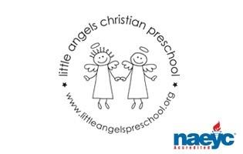

March 2018

Toddler Newsletter – Loppnow/Katzbeck/Schaefer

Hello, Toddler Parents! We are hoping to head into spring this month with more outdoor time for our toddlers. Assume we will go out daily and pack the appropriate attire according to the weather. March fun will kick off with learning and playing opportunities exploring our senses, St. Patrick’s Day, the color green, rainbows and nature.

We will have parent-teacher conferences the morning of Thursday, March 22. Please let us know if you will not be available on this date. We will write up a schedule and have it posted soon. Thank you!

Reminder:
Parent-Teacher Conferences March 22
No school March 23- April 2

Your Toddler Teachers,

Laura Loppnow, Lynda Katzbeck and Christine Schaefer
