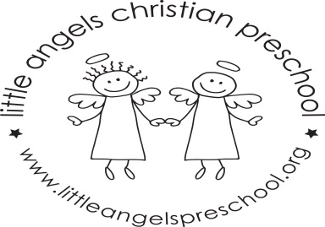

March Newsletter Two’s Class
Dear Parents,
Thank you all so much for the very generous books donated to our class during the book fair, we will enjoy reading them to the children.
During March our themes will be “Touch and Hands”, “St. Patrick’s Day” and “Smell and Noses”. We will have dress up clothes, housekeeping and a pet vet in the dramatic play area. Green table covers, napkins, plates etc, for St Patrick’s Day. For art we will use finger paints, crayons on sandpaper, make a shamrock wreath and paint with watercolors. We will also experiment mixing together blue and yellow paints. We have a wide variety of table toys including puzzles, play dough and matching games. We will sing “5 Senses Song”, “Head Shoulders Knees and Toes” and dance an Irish jig!! The children also enjoy their time with Mrs. Oehler during our music class each week.
We will not have school on Friday March 23rd and for the week of March 26th due to Spring Break. We hope you have a blessed and relaxing break wherever you are spending it. As always, please do not hesitate to call, email or stop by with any questions or concerns.
Martha Carroll and Maggie Killick

