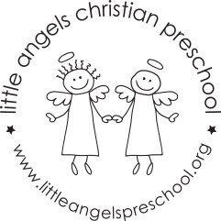
Dear families,
Toys and games include puzzles, various table blocks, small construction materials such as Legos, board games, and collections of objects (including shells, bottle caps, and buttons). When children use toys and games, they explore how things work; learn to be creative and use their imaginations; strengthen and control the small muscles in their hands; work cooperatively and solve problems; and learn math ideas and concepts.
When children use toys and games in the classroom, we encourage them to talk about what they are doing. For example, we might say:
- Tell me about the design you made.
- How did you get those rings to fit together?
- You’ve picked out all blocks that look the same. Can you tell me how they are the same?”
These questions and comments are designed to help children develop their thinking skills.
What you can do at home
You play an important role in selecting toys and games that are safe, interesting, and appropriate for your child’s abilities. More importantly, research shows that the most creative children are those who have had adults involved in their play. Here are a few ways that you can be involved in your child’s play with toys and games:
- Observe. Watch as your child plays and notice his abilities and his interests.
- Play. Follow your child’s lead and join in his play
- Imagine. Keep in mind that there’s more than one way to play with a toy. Be creative!
- Enjoy. This isn’t time to drill your child or test him on what he knows. Just have fun being together, talking and playing.
Good toys do not have to be expensive. You might collect various small objects such as buttons, seashells, rocks and plastic bottle tops. Make suggestions such as sort all the buttons that are the same color or all the beads that are the same size. Encourage your child to tell you about the design he or she is making or to explain why things belong together.
Playing with toys and games at home promotes a child’s development in many ways.

Duplicated with permission from The Creative Curriculum for Preschool.

