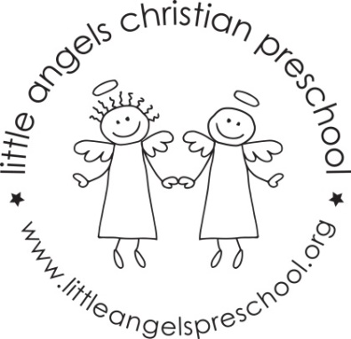

Newsletter January 2018
Dear Parents,
Welcome back, we hope you had a blessed and wonderful Christmas and New Year. Thank you all so much for the generous gifts, we really appreciate them.
We have planned some new and exciting activities for January. Our themes will be winter with snow, penguins and shapes.
Our art activities will include painting with brushes, using glue sticks to make a collage and painting with popsicles. We will build with both wooden blocks and texture blocks. To develop our fine motor skills we will work with play dough, manipulative toys and puzzles.
Our dramatic play area will include a doctor’s office, housekeeping and a pizza parlor.
Mrs Oehler our school music teacher will visit us once a week beginning in January for our music class, we are very excited about this! Ms Julie will also continue to visit each week for our Chapel time.
Reminder: No school Monday Jan 15th – Martin Luther King Day
Happy New Year!
Martha Carroll and Maggie Killick

