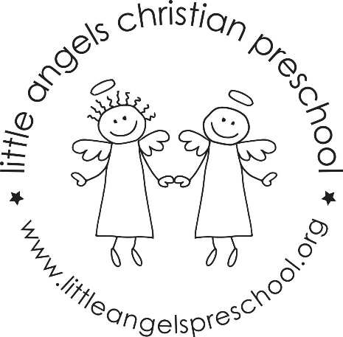

December Newsletter
Three Year Old Class

Dear Parents,
We hope everyone had a fantastic Thanksgiving with family and friends. We can hardly believe it’s the month of December! This month we will discuss with the children the true meaning of Christmas. We will remind the children that even though we give and receive gifts, it is also Jesus’ Birthday.
We have already begun practicing the songs for our Christmas program! Mark your calendars for Thursday December 21, at 6pm. It will be a great opportunity for you to see what your children have been working on music.
The next couple weeks will be very busy in our classroom. We will be working hard on a special gift for you! The room will be decorated in holiday décor, stop by and look if you get a minute. There is a tree that the children will be making ornaments for.
We will continue to go out to the playground as weather permits. Be sure to remember hats and mittens as the weather grows colder.
There will be no school December 25-January 8. January 11/12 we will be having a hibernation party at school! Details will follow, but will involve wearing pajamas to school!
We’d like to offer a special welcome to Elsie Williams, joining our MWF class. The Williams family is returning to Barrington after living in Georgia for a year. So be sure to welcome them back!
We are always available if you have any questions or concerns!
Your three year old teaching team:
Sue Dreys and Anne Gierthy

