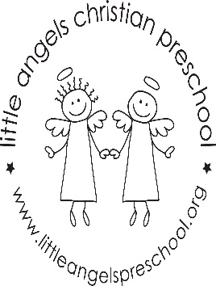2’s December Newsletter 2017

Dear Parents,
We are looking forward to sharing this magical time of year with your child. We have many new and exciting activities planned. During the entire month our theme will be Christmas. We will focus on Baby Jesus’ Birthday, Christmas trees and wreaths and of course Santa Claus.
Our dramatic play area will be transformed into a cozy house area with a tree and fireplace. We will add stockings, baking items and new ornaments for the tree.
For art we will do painting and gluing and work on a secret Christmas surprise. We are anxious to share new stories, songs and flannel boards with the children. If you hear them humming some new tunes don’t be surprised.
We will still be going out every day that the weather permits so please send all their outdoor gear!
We hope you and your family have a very blessed holiday season.
Martha Carroll and Maggie Killick

