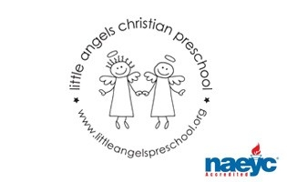

November 2017

Toddler Newsletter- Mrs. Finnegan & Mrs. Loppnow

Hello Toddler families! Here is a preview of what your little ones are in for this month: The first week we’ll pivot from Halloween and have a unit on Transportation. For “Air and Water Transportation” we’ll have dramatic play with airplanes, helicopters and boats along with water and sand play. Then we’ll have a session dedicated to “Trains” and next “Cars and trucks” with a couple of neat art activities where the children will “drive” marker trains and then paint with car wheels.

As we approach Thanksgiving we will have many Thanksgiving stories, play at holiday baking and for science explore the insides of gourds, squash and pumpkins.
There will be an all school Thanksgiving Feast on Monday Nov 20 and Tuesday Nov 21 during the morning where all classes present that day will come together and share a special snack in the community room. We’ll be sure to send home pictures!

Reminders/Important Dates:
• Please send your child with hats and mitts (label please) and have your child practice wearing them. When we go outside we want the children to be comfortable!
• Mon November 20 and Tues November 21 - All school feast during morning
• Wed November 22 – Fri November 24 - NO SCHOOL, THANKSGIVING BREAK

Enjoy the start of this holiday season and as always thank you for sharing your children with us!

Your Toddler Team,

Mrs. Allison Finnegan and Mrs. Laura Loppnow

