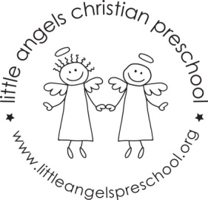
November newsletter
Dear Parents,
The children have settled well into our classroom and we are really enjoying getting to know them.
For the month of November our themes will be transportation and Thanksgiving. We will have feathers and cotton balls in the sensory table and the table will also be a car wash! For art we will dip school bus wheels in paint, and also paint with feathers and kitchen utensils. We will make a cute texture train using glue sticks.
During the first week of November we will have a school bus visiting for the children to explore while parked outside. This will be on Monday the 6th and Tuesday the 7th of November.
We will be singing “My Little Turkey”, “This Little Train” and “The Wheels on the Bus” as well as learning some new flannel board stories and reading some books including “I’m Your Bus” and “ Best Thanksgiving Ever”. We will be having a special Thanksgiving snack with all the children in the school on Monday and Tuesday November 20th and 21st.
During November we will be talking to the children about what being thankful means and Ms Julie will continue to visit us once a week for our Chapel time. The children enjoy the props she brings and the bible stories she teaches us.
There is no school Friday November 3rd – In Service day.
Thanksgiving break is November 22nd – 24th.
As the weather gets colder we will continue to go outside unless it is raining or too cold, please make sure your child’s outdoor coat is labeled with their name. Please put hats, gloves etc. into the sleeve of the coat. We are not able to look in each child’s backpack for these. Thanks!
God bless you and your family and have a blessed Thanksgiving.
Martha Carroll and Maggie Killick

