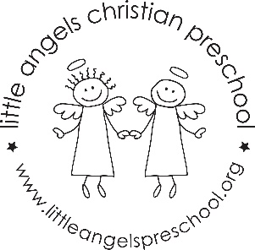October Newsletter

Dear Parents,
Welcome to October. We are very pleased to report that most of the children have settled into the class quite nice and we are very proud of them. We look forward to chatting with you about their initial adjustment at conferences. This month our themes will be Apples, Farm, Leaves and Pumpkins. We are excited to offer new sensory experiences, process art activities and circle stories and songs. Our white board will keep you posted on our daily activities.

Our conferences are scheduled for Thursday October 19th. Please let us know if you are unable to attend.

Our Fall parties will be at the end of the month. They are sure to be a fun event. Everyone is welcome to attend.

We will continue to go outdoors when weather permits so please label your child’s outerwear so we can avoid any mix-ups.

As always we are available if any questions or concerns arise.

HAPPY FALL!
Martha Carroll and Maggie Killick

