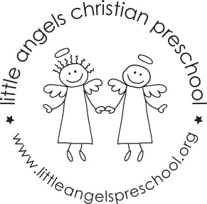
October 2017

M/W/F and T/TH Threes parents
We have really settled into our new class this year and each day is bringing us new experiences and opportunities to get to know your child. The month of October is sure be a very busy time for the Three year old classes. We have many fun and educational things planned for your child. Our themes will be: Families, Where I live, Fall, Pumpkins/Halloween and Air and water transportation. Our dramatic play area will change weekly based upon our theme. There will be doll houses, fall housekeeping, and family puppets at our puppet theatre. For art, the children will paint a group tree and then decorate it with leaves that contain the child’s last name. There will be many other art activities which will include painting with brooms, apple prints and pumpkin painting just to name a few. The sensory table will change as well as our group time activities to coincide with our theme for the week. The children seem to be enjoying our chapel time with Miss Julie and music with Mrs. Oehler! We have also been meeting our Letter People and learning the sign language to go with it! The children seem to be catching on to this quickly!
Conferences are coming soon….please be watching your child’s cubby for the sheet that we send home before conferences.
Thank you to our room parents: Amy Davis and Kristin Johnson (MWF Threes) and Leann Chan and Stacy Patrick (T/TH Threes).
You should be receiving an email about our Fall/Halloween party soon from our room parents.
Dates to remember:
October 1 – The pumpkin patch opens in front of the church
October 14 Fall Fundraiser @ McGonigals
October 19 – Conferences (No School)
October 20 – No School
November 1 and 2 – Bishop Joseph from the Sudan will visit with the children during our chapel time.
Thank you for sharing your child with us and if you ever have any questions or concerns we are always available! Sue Dreys and Anne Gierthy

