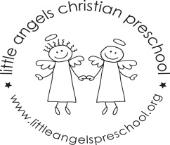
September 2017 2’s Newsletter

Dear Parents
Welcome to our Little Angels two-year-old program, we hope you had a wonderful summer and are looking forward to getting the school year started. We are very excited to start the new school year and especially excited about getting to know the children and their different personalities
During the month of September the children will be exploring the classroom and of course our beautiful new playground as they adjust to separating from their care givers. Our themes will be “All about me”, “Friends” and “Families”. we will be doing some fun projects including art, play dough, finger plays and reading many favorite stories.
To help the children transition into the classroom, please bring in a family photograph which we will display for the children to look at and also a picture of your child standing outside your house. Thank you!
We hope you all will be able to attend the ice cream social on Thursday September 14th from 5.30 – 6.30pm; it is always lots of fun.
School photo days will be during the week of Sept 18th to Sept 22nd more details to follow!
Please make sure that you child has diapers (if needed) and a change of clothes in their backpack in case of accidents. Also, please label all clothes, jackets, coats etc. with your child’s name.
We look forward to a terrific year and getting to know all of you. If you have any questions or concerns, please don’t hesitate to get in contact with us.
God bless you and your family,
Martha Carroll and Maggie Killick

