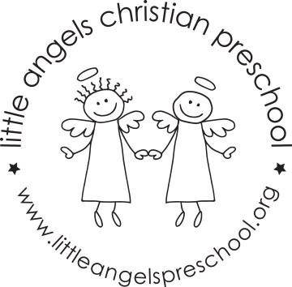
September 2017
T/TH Three year old class newsletter
Welcome to the Little Angels three year old class! We are excited about the school year and can’t wait to get to know you and your child. We have been busy preparing the classroom and planning fun learning activities.
During the month of September we will spend time getting to know each other and our new room. We will talk with the children about their unique qualities and their family structure within our theme “All about me!” We will explore our emotions and talk about the diversity of our families. At the end of the month our theme will be “Friends”. We will make a friendship snack and have fun table games using pictures of the children.
Each month you will be able to go onto our website to read our classroom newsletter. We will also be posting a parent letter from our Creative Curriculum materials (which is what we use to develop our themes and activities). These parent letters will explain the benefits of each area of our classroom. September is the only month that you will receive a paper copy of the newsletter! Please check out our website at the beginning of each month. You can go to www.littleangelspreschool.org and select “enrolled families”, “class pages” and then click on T/TH Threes class.
Please make sure that your child has an appropriate change of clothes in their backpack and diapers/pull-ups if still needed. Also, please make sure that all items are labeled with your child’s name.
We have an email address for our classroom. We will only check it before and after class. So, if you have something that you need us to know right away, you should call the school office (847)381-5490. If it’s something that does not need immediate attention, please feel free to use our classroom email. The address is: threes@littleangelspreschool.org
We hope to see you at the ice cream social which will be on Thursday, September 14th. It’s fun for us to meet the whole family, show off our classroom and eat ice cream!
We are looking forward to having a great year!
Your three year old teaching team:
Sue Dreys and Anne Gierthy

