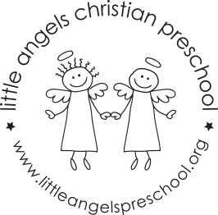May 2017 – Three year old class
WOW! We cannot believe that this school year is over in just a few weeks! It has been such a pleasure working with your children. They have grown in so many ways this year (and so have we as teachers!) These last few weeks will be loaded with fun activities.
The first week we are talking about the Three Little Pigs and the Big Bad Wolf. We will have a brick wall in our house area and will have interesting things to build houses with in the sensory table.
The second week we will be talking about Goldilocks and the Three Bears. We will have many opportunities to talk about small, medium and large things. We will graph bears and do some patterning too. It’s always fun to act this out in dramatic play with bear ears and Goldilocks hair!
The third week of May we will be talking about Community helpers. We will be putting “fires” out and setting up a post office in the dramatic play area.
Crazy days are crazy! The last week of school we will be doing whatever the children want to do (within reason!) We will look back at their favorite activities and do them during these last two days of school. Beach volleyball, blowing up a volcano and washing babies in the sensory table are just a few of the thing that we remember the children enjoying.
We will have a visit from the Spanish teacher on May 15 and 16. Senora Kimes will come into our class to give us a preview of what we have to look forward to for the next school year. We will also go into the four year old classrooms for a sneak peek of the rooms.
Please remember to mark your calendar for our all school picnic on Friday, May 26. We will provide the food so that you and your children can come and enjoy our end of the school year picnic!
Thank you for a great year!! Sue Dreys, Claire Conners, Roberta Ball

