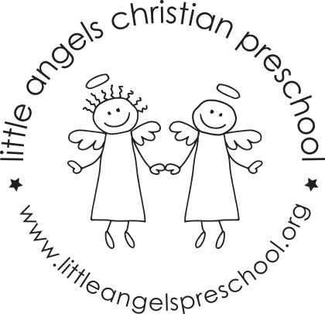

May 2017 Newsletter
Wow, this school year has just whizzed by. It’s hard to believe that it is May already!
We have really enjoyed this year, getting to know all of the children, enjoying their different personalities and watching them become so comfortable in our class. We hope you pop in and say hi to us next year!!
During May, our themes will be gardens, fruit and veggies and kids choice. We will have some fun activities to go with these themes. The last week will be crazy days! We will sing “The Pumpkin on the Vine” and some other favorite activities the children have especially enjoyed this year. In the sensory table we will have dirt with plastic flowers, water and sand.
For art we will make flower prints, paint with fruit and veggies, have free art for kid’s choice and further develop our small muscles using stickers. Our dramatic play area will be a flower shop, fruit and vegetable stand and housekeeping with babies and strollers.
We will be reading “Garden Pop-up Book”, “Muncha Muncha” as well as some of the children’s favorite stories, songs and flannel boards they have enjoyed this year.
We hope you will join us for the all school picnic on Friday May 26th this is always a fun day for everyone, more information will be sent home soon.
Thank you for sharing your children with us and have a great summer.
Martha Carroll and Maggie Killick

