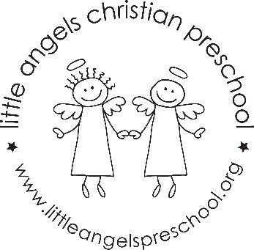2’s April Newsletter

Dear Parents,
We have a very busy April planned for your child. Our themes for this month are Easter and “Our Earth”. We will also be celebrating “Week of the Young Child”. This correlates with our NAEYC accreditation and we have many fun activities planned.
Some of our art activities will be pom-pom painting, gluing tissue paper and dot paints. We have new flannel boards, songs and stories for our circle time. We will also have new sensory experiences that include rainbow rice and shredded newspaper.
We will continue to have our music and movement time with Mrs. Oehler and chapel time with Miss Julie. As always we will try to get as much fresh air and sunshine as possible so please dress your child accordingly.
We will be having conferences on Wednesday April 12th if you would like to meet with us. Please look for the sign-up sheet next week. Please do not hesitate to contact us if you have any questions or concerns.
Happy Spring!

