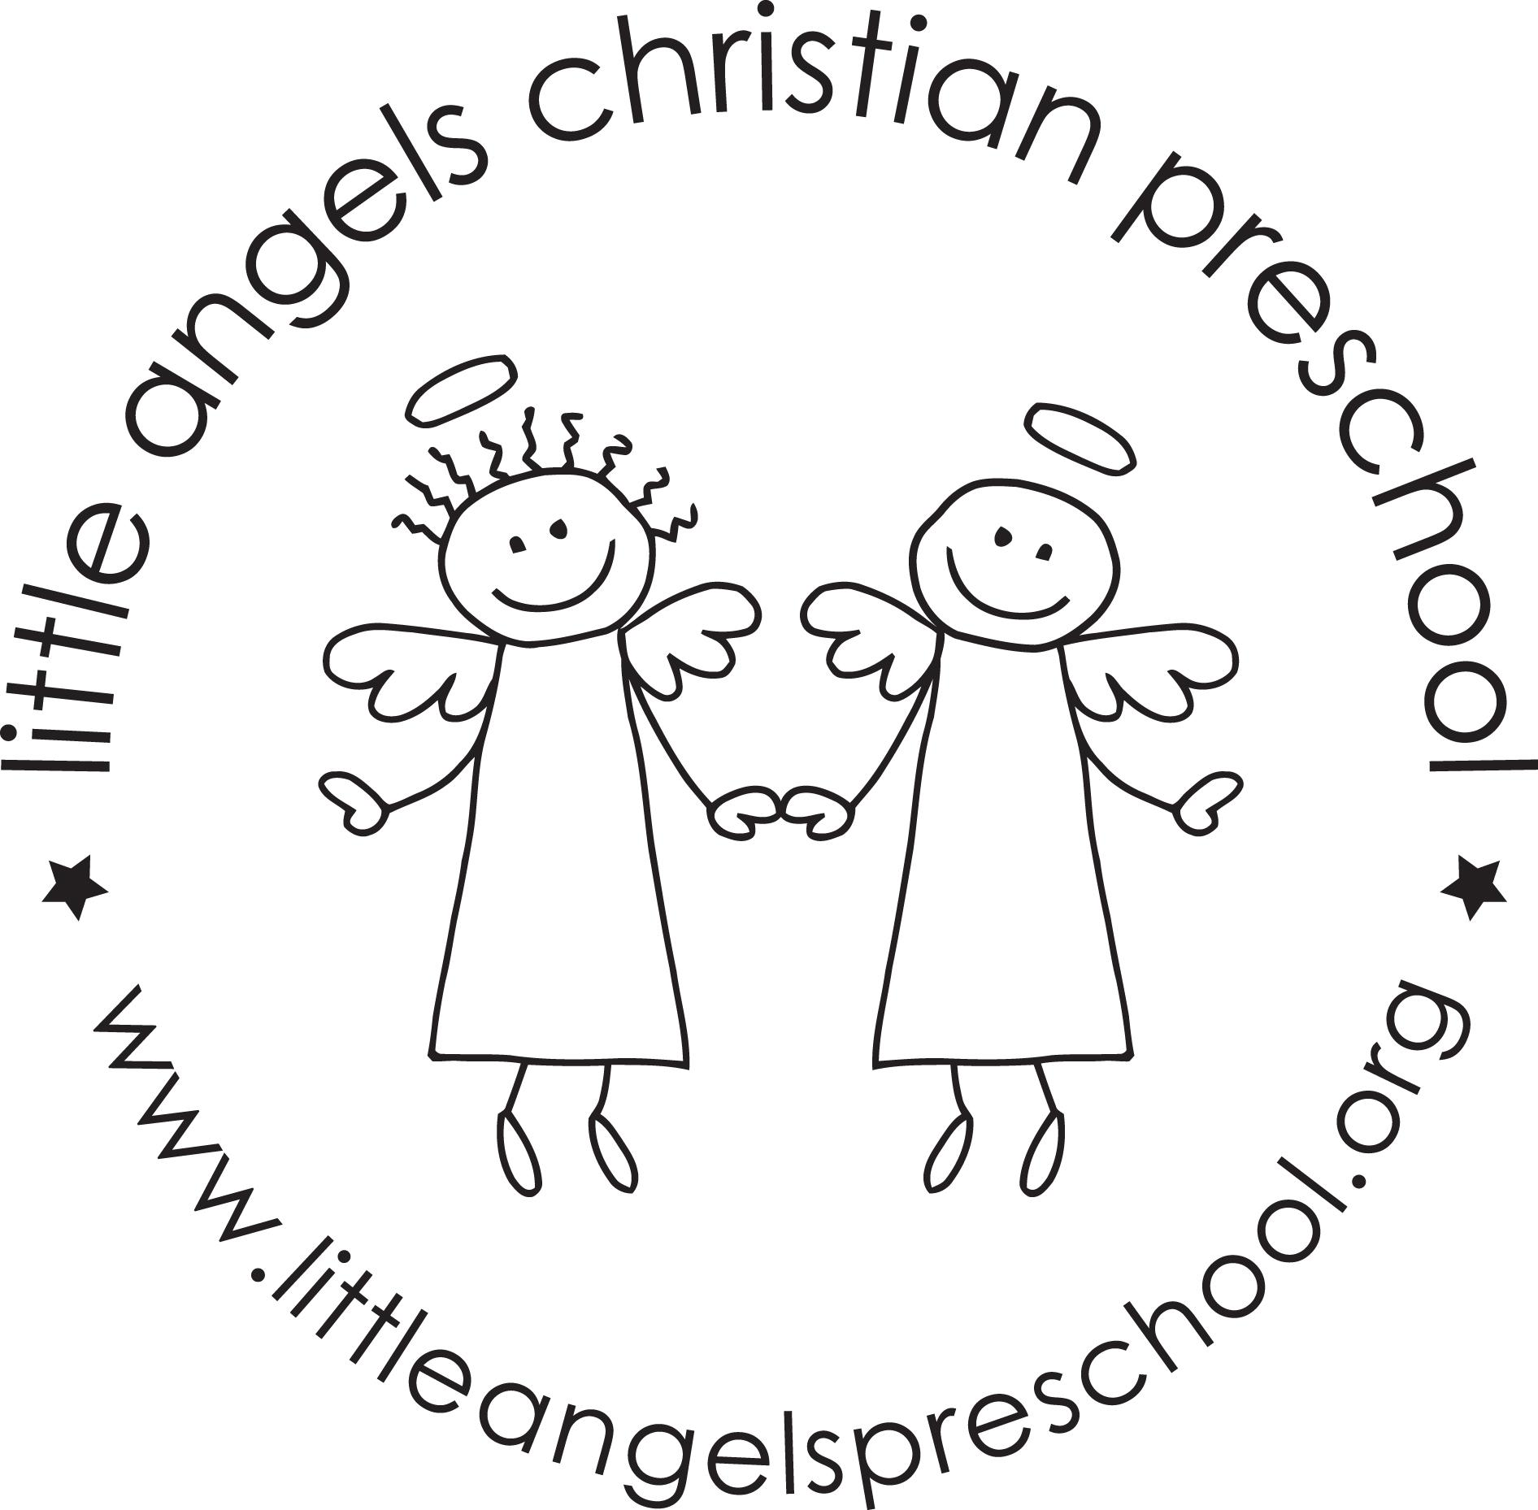

March 2017

Toddler Newsletter- Finnegan/Webber/Oehler

Hello toddler families! We have many fun activities planned for the month of March. To start the month we will be focusing on our sense of taste, smell, and hearing. One of the activities will be painting with toothbrushes on mouth shapes. The second week will be St.Patrick’s day theme and the kids will enjoy searching for gold coins in the sensory table filled with rice. Third week will be under the sea and we will have water and seashells in the sensory table. Then it will be spring break! Spring break dates are March 24-April 2, with school resuming on Monday April 3rd.

Please remember to update your child’s change of clothes in their backpack as the seasons change and they grow out of their previous set!

Your toddler team,
Ms. Webber, Mrs. Finnegan, and Mrs. Oehler

