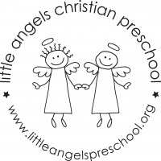 March 2017
Three-Year-Old Classes

This year has been flying by! We have quickly headed into a fun-filled March, and we are so excited for all the fun we have in store for your children this month!

We will be spending a majority of this month talking about the five senses. We will talk about how much our five senses help us in our everyday life and what is special and unique about each of them. We will be doing themed art work such as texture collages, as well as exploring different types of mediums of paper we can create art on. Our table activities are very engaging and versatile; they include exploring different textures, finding how different sounds are created and using our senses of smells. It will be a fun month learning about all that our senses help us with!
This month we will also be celebrating St. Patrick’s Day! Our room will be decked out in green shamrocks and leprechauns! The week of St. Patrick’s Day we will have a lot of fun with themed artwork and and green table activities!
We have been moving along with our letter people and started this month with “Mr. T” and have been practicing the corresponding sign language and we will be continuing all the way through “Z.”

We hope your children have been sharing with you all that they’ve been learning this year and look forward to all the fun learning we still have in store this year!

Reminder: We will be closed for Spring Break from Friday March 24- Friday March 31

Your Three’s teaching team- Sue Dreys, Claire Conners and Roberta Ball

