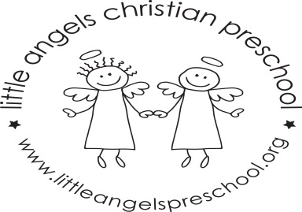

March Newsletter Two’s Class
Dear Parents,
Thank you all so much for the very generous books donated to our class during the book fair, we will enjoy reading them to the children.
This month our themes are “Sight and Eyes”, “St. Patrick’s Day” and “Spring”. We will have housekeeping in the dramatic play area as well as a flower shop. For art we will paint with watercolors, glitter paints and further develop our small muscle skill using glue sticks to make a color collage. We will also experiment mixing together blue and yellow paints. We have a wide variety of table toys including puzzles, play dough and matching games. We will sing “Itsy Bitsy Spider” and dance an Irish jig!! And as always revisit some of the children’s favorites. The children also enjoy their time with Mrs. Oehler during our music class each week.
Keep your fingers crossed and hopefully we will enjoy fresh air and sunshine soon. We will not have school Friday March 24th and the week of March 27th due to Spring Break. We hope you have a blessed and relaxing break wherever you are spending it.
As always do not hesitate to call, email or stop by with any questions or concerns.
Martha Carroll and Maggie Killick

