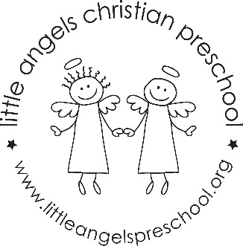
Two’s February Newsletter
Love is in the air!!! To start the month off our themes are “HEARTS”, “LOVE” and “VALENTINE’S DAY”. We will have a mailbox with cards and decorations in the dramatic play area. We will have new art activities as well as stories and songs. We are introducing a Valentine hopscotch game for large motor. The sensory table will change from sand to water to crinkle paper with various items added in.
Our other themes for February will be “OUR 5 SENSES”. We will draw to music, have taste tests and paint with different textures. We will be very busy with all of our new discoveries. We will continue to have Chapel Time with Miss Julie and Music lessons with Mrs. Oehler. We hope to be getting more fresh air so please send your child with the appropriate labeled outerwear.
Party days are the 13th and 14th…hope to see you there!
Martha Carroll and Maggie Killick

