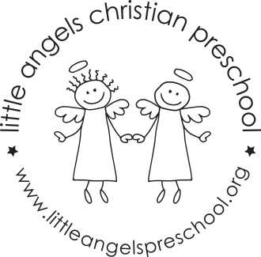
January 2017!
Three year olds
Welcome back! We hope you had a great Christmas Break filled with a lot of family fun time! We want to say thank you for all of your thoughtful and generous gifts, it always makes us feel appreciated! We are excited to have the children back at school and are looking forward to a great 2017!
We are starting the month of January out talking about snow. We will move into a theme about Forest animals and what they do in the winter and then go back to snow and ice for the last week of January. We have many fun and educational things planned such as: making ice cube structures for penguins, riding sleds in the dramatic play area, learning snowman finger plays and playing with real snow (if we have any!) Hopefully, we will be able to compare fake snow to real snow. Using magnifying glasses to look closely at snowflakes will be interesting since no two snowflakes look alike.
We are a little more than halfway through meeting our letter people and learning each letter in sign language to go with them. We will continue learning the letters in sign language and will start learning some words too. Eventually, we will learn a whole prayer in sign language!
There are some new things coming up for our class in 2017. We will be cutting the children’s pictures off of the check in cards. Hopefully, the children are all recognizing their names by this time but, if not, they will learn very soon! We will also start practicing using a child sized pitcher with water. This will get the children ready to pour their own water refills at snack time later in the month.
We do go outside in the winter if the temperature is at least 20 degrees (including the wind chill). So, please make sure that you bring your child’s winter gear to school. It would be helpful for us if you put your child’s hat and mittens either in the sleeve of the coat or on the top shelf of the cubby. Thank you in advance!
Reminder: We will be closed on Monday, January 17th.
Your three year old teaching team
Sue Dreys Roberta Ball Claire Conners

