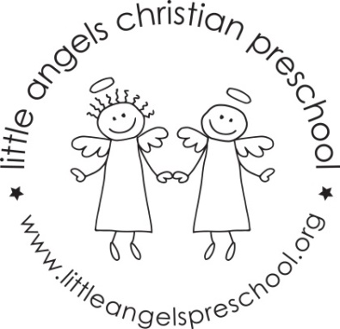

Newsletter January 2017
Dear Parents,
Welcome back, thank you all so much for the generous gifts, we really appreciate them. We hope you enjoyed your Christmas and New Year holiday as much as we did!
We have planned some new and exciting activities for January. Our themes will be winter with snow and penguins, pets and shapes.
Our art activities will include painting with glitter paint, using glue sticks to make a collage and using frozen watercolor paints. We will build with both wooden blocks and texture blocks. To develop our fine motor skills we will work with play dough, manipulative toys and puzzles.
Our dramatic play area will include a grocery store, doctor’s office, a pet store and housekeeping.
Mrs Oehler our school music teacher will visit us once a week beginning in January for our music class, we are very excited about this!

Reminder: No school Monday Jan 16th – Martin Luther King Day
Happy New Year!
Martha Carroll and Maggie Killick

