2’s DECEMBER NEWSLETTER
Dear Parents,
The month of December is finally here and we are very excited to share this magical season with your child. We will be introducing the “Nativity” and also many other seasonal well- loved stories. We will sing holiday songs and have fun with jingle bells and other instruments. We will decorate trees, paint with glitter paint and work on special gifts. We will change the sensory table and dramatic play and we are sure the children will enjoy these new experiences. Miss Julie will continue to join us once a week for our chapel visit as well as our Smart Board time in the 4’s room.
We are looking forward to getting together for our holiday parties. 12/20 and 12/21 at 11:00a.m
Reminder: Please label your child’s outerwear and place hats and mittens in the sleeve of jackets. It’s a challenge to get 12 children dressed and this truly helps us out!
Don’t forget that we are always available if you have any questions or concerns.
HAPPY HOLIDAYS! 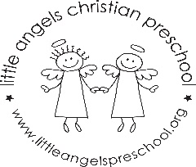 Martha and Maggie

