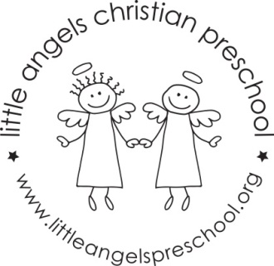

Twos Newsletter November 2016

Dear Parents,
Thank you so much for the very generous donations you made at our fundraiser (both in volunteering your time and all the donations). We are so excited about our new playground!
For the month of November our themes will be, land transportation (cars, buses, trucks), air and water transportation, Thanksgiving and then trains.
Our art projects will include, painting with cars, using watercolors, and painting with kitchen utensils. We will have sand, feathers and cotton balls in the sensory table and the table will also be a car wash!
We will be singing “My Little Turkey” and “The Wheels on the Bus” as well as learning some new flannel board stories. During the first week, land transportation we will have a school bus visiting for the children to explore while parked outside. This will be on Wednesday & Thursday November 2nd and 3rd.

There is no school Friday November 4th – In Service day.
Thanksgiving break is November 23rd – 25th.

As the weather gets colder we will continue to go outside unless it is raining, please make sure your child’s outdoor coat is labeled with their name. Please put hats, gloves etc. into the sleeve of the coat. We do not look in each child’s backpack for these.

God bless you and your family and have a blessed Thanksgiving.
Martha Carroll and Maggie Killick

