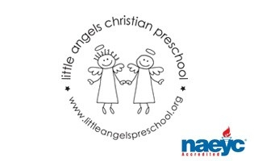

October 2016

Toddler Newsletter – Finnegan/Webber

We are off to a great start to our school year! We are so pleased to see your little ones getting acclimated to the room, their teachers, routines and each other!

The month of October will be largely thematic of Fall: the first week we’ll be down on the farm with a farmers market in dramatic play, books about farm animals and activities centered around apples. Week two the theme will shift to leaves and the third week will be all about pumpkins. The final week will reflect the fun of the season and upcoming Halloween but without the “spooky”. We will introduce playing with dress up and the children will be welcome to wear a Halloween costume or a Halloween themed outfit on Thurs Oct 27th, Fri Oct 28th or Mon Oct 31st - the day of their respective Fall class party. Please, for the children’s safety and comfort: No weapons, accessories or masks, and only outfits that are easy off and in which they will not overheat! Throughout the month we will also focus on a woodland animals: squirrels, owls, raccoons and skunks.

Toddlers’ Fall conferences are scheduled for the morning of Thursday Oct 20th. We will have a sign up outside the classroom starting the first week of the month. We will send home a written progress report focusing on social and emotional adjustment that we may discuss at this time. We hope you can join us - let us know if you have a conflict or specific scheduling need and we will try to accommodate you.

Reminders:
• Please be sure to dress your child for the fluctuating weather – we love to go outside and want the children to be comfortable.
• Please label every item with your child’s name as they sometimes don’t identify what belongs to them.
• School IS in session on Mon Oct 10th – Columbus Day
• No school on Thursday Oct 20th and Friday Oct 21st due to school-wide conferences. Look for sign up sheet outside our classroom.

Thank you for sharing your children with us. They are such fun!

Your toddler team,

Nan Webber and Mrs. Allison Finnegan

