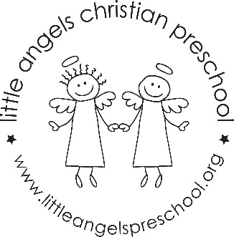

Two’s October Newsletter

We are very excited to be teaching your little ones. All of the children have settled in nicely and appear to enjoy their time at school. During the month of October our themes will be “Farms”, “Leaves”, ”Apples” and “Pumpkins”. All of our learning centers will change with our themes. We will have new art activities such as finger painting, apple and pumpkin prints and even cookie cutter painting. The sensory table will have foam apples, sand and many other experiences. We will begin teaching some new songs and introduce interactive flannel board stories. Keep reading our daily emails for more details.
Our conferences will take place on Thursday October 20th in the morning. Sign-up sheets will be near the sign in book.
We are looking forward to our fall party and hope everyone will join us. The parties will be at 11:00 a.m. on October 27th and October 31st
If you have any questions or concerns please do not hesitate to ask.
Happy fall!
Martha Carroll and Maggie Killick

