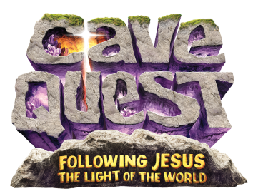
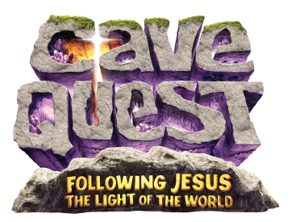
Vacation Bible School 2016
CAVE QUEST
June 6th— 10th 9:00—12:15
For 4 year olds to graduated 6th graders

At First Presbyterian Church
13th Street West and Poly Drive
406-252-3434 or mainoffice@fpcbillings.org
Please return this registration form to First Presbyterian Church ASAP

Parent’s Name(s):___________________________________________ Ph:_____________(h)_____________(w)_____________(c)
Address:_________________________________________ Zip:_________________ E-Mail:_________________________________
Parent’s Home Church:____________________________________________ Is Parent interested in helping with VBS?____________
Are you a guest?____________________ If so, who invited you?_______________________________________________________
Child’s Name:_____________________________________________________________ Grade completed:_________ Age_______
List any medical concerns or allergies (esp food) ____________________________________________________________________
Child’s Name:______________________________________________________________Grade completed:_________ Age_______
List any medical concerns or allergies (esp food) ____________________________________________________________________
Child’s Name:_____________________________________________________________Grade completed:_________ Age________
List any medical concerns or allergies (esp food) ____________________________________________________________________
Child’s Name:_____________________________________________________________Grade completed:_________ Age________
List any medical concerns or allergies (esp food) ____________________________________________________________________

**Person to call in case of emergency, if parents cannot be reached:
Name:_____________________________________________ Phone:_______________________
I/We give permission for the children listed above to participate in all VBS 2016 events. In case of emergency, I/We authorize the persons in charge to take measures they feel are in the best interest and welfare of the children, including emergency medical care. I/We will not hold the church, its staff or persons assisting the program responsible for expenses incurred. I/We release First Presbyterian Church for any liability.
Parent / Guardian Signature:________________________________________Date:_________________
Children’s Physician’s Name:____________________________________________Date:________________
Donations are appreciated to cover the cost of materials and activities
(Cave Quest carnival will be held on Friday Evening June 10th 6:00p.m.)

