***Rev. Dr. Arthur L. Brown***

***9 th Pastoral Anniversary***

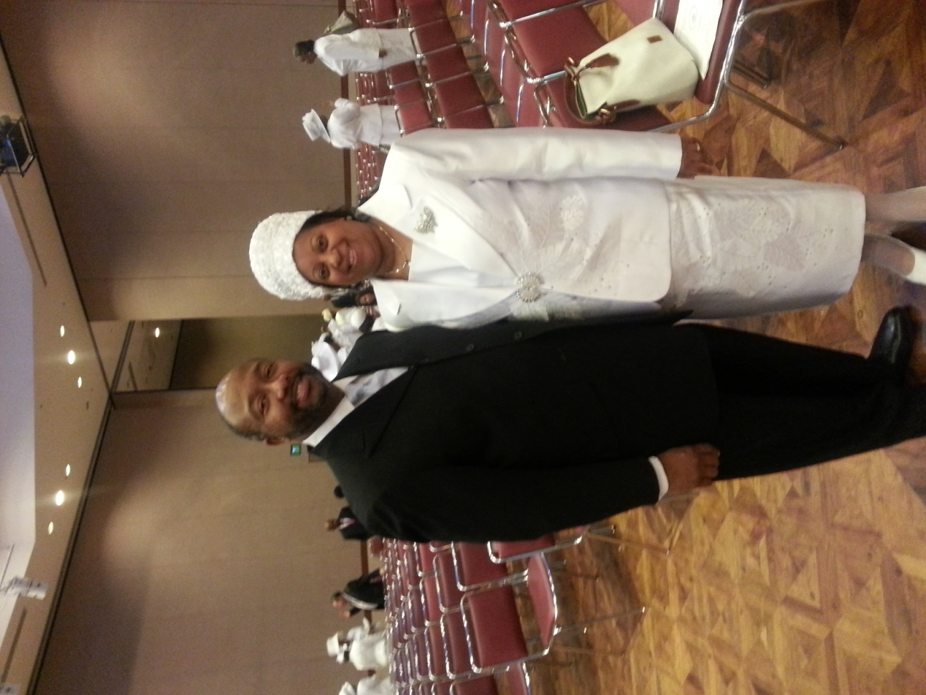***Tabernacle Baptist Church***

**Sunday, May 24, 2015**

**C:\Users\Deborah\AppData\Local\Microsoft\Windows\Temporary Internet Files\Content.IE5\M6KAAAR1\MC900361874[1].wmf**

**11:00 A.M. Morning Worship**

Rev. Dr. Aaron Willford, Jr. Pastor

Bethlehem Baptist Church

York, PA

**3:30 P.M. Afternoon Service**

Musical Celebration

For more information, please contact Mrs. Jessi O. Brown in the church office at (717) 236-1774

**Deaconess Earline Bowser, Chairperson**