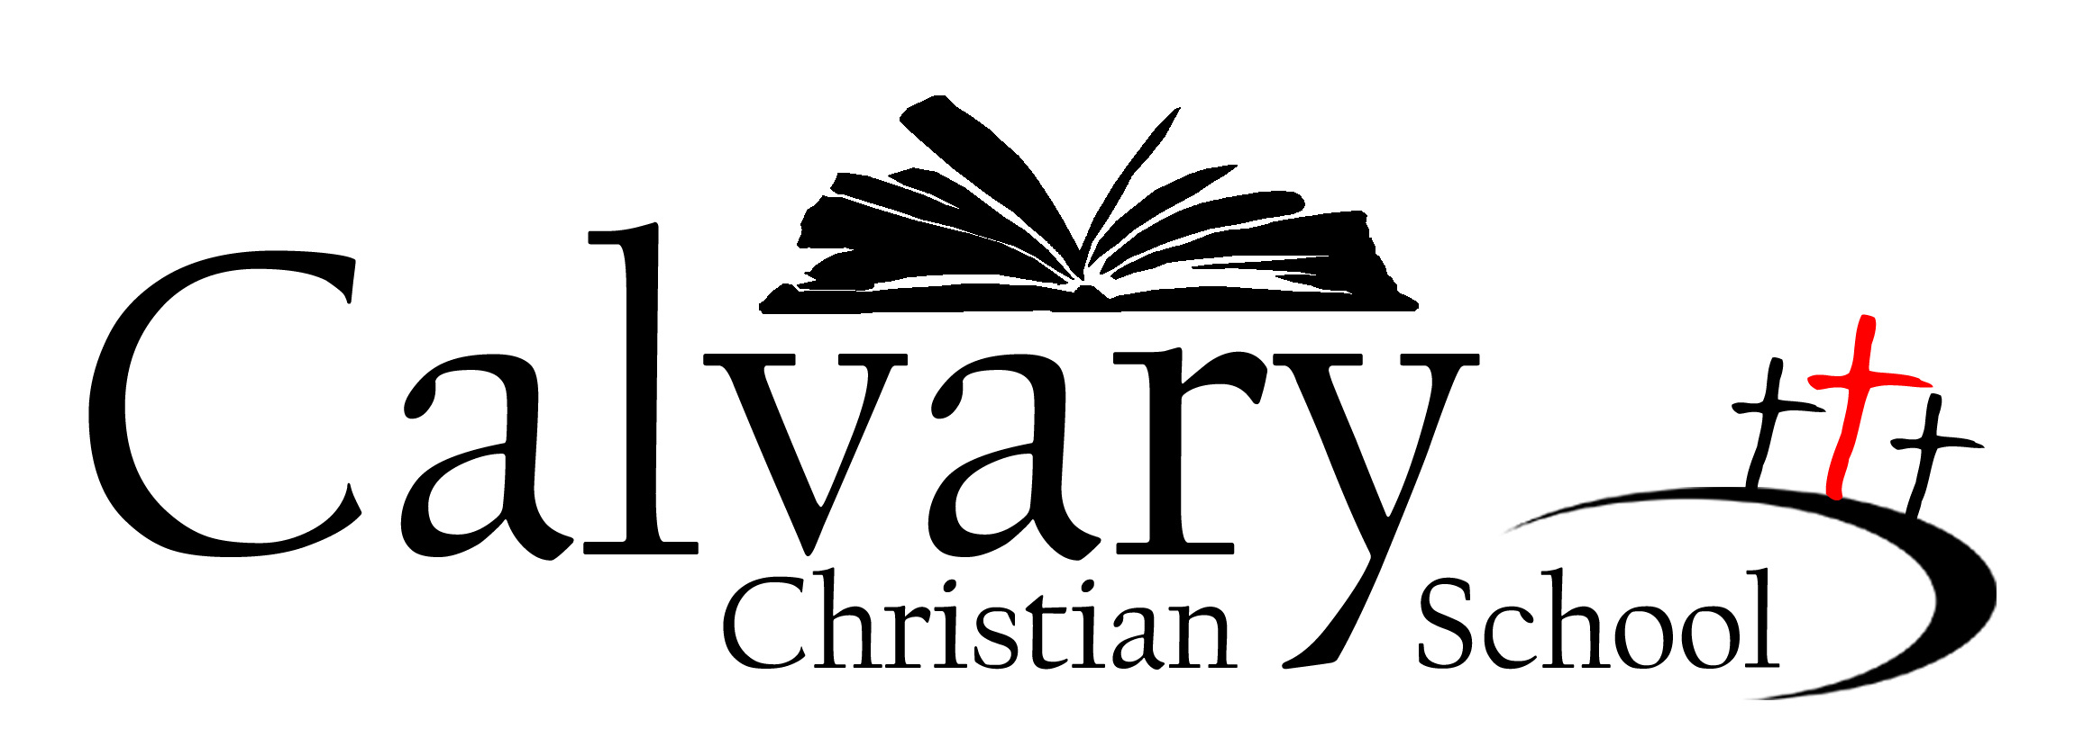
15 Redwing Drive
Winchester, KY 40391
(859)744-0817 / Fax (859)744-9204
www.calvaryskids.net

Brian Walton, Senior Minister Ned Hess, Principal

The concluding days of the 2008-2009 school year are upon us. With this letter, it is my desire to recap the year and preview some changes for next year.

Several highlights define my first year at the helm. The faculty and staff are a seasoned group committed to service and excellence. Notwithstanding the motherhood clause, all plan to return next year. Jen Gurney will deliver her third child and return to teach private piano lessons; Lindsay Flynn will stay home to care for her newborn son. We will miss them both!

The students are well-behaved and studious. They have an admirable work ethic. In a comparative review of Stanford and OLSAT testing, our students are overachievers. Orderly classrooms and a supportive community produce that output. Our Stanford test results which compare our students against their peers nationally are solid. Without any teaching to the test, our classes rank in grade equivalency/national percentile rank as follows:

First-2.2/70.6 Third- 4.5/66.6 Fifth- 6.8/67.6 Seventh- 9.3/74.6
Second- 4.2/76.6 Fourth- 7.2/76.6 Sixth- 7.5/51.5

All class scores exceed the norm. To protect and ultimately improve those scores, an Admissions Committee has been formed which evaluates all incoming students. Prospective students must score within 15% points of the current class to be considered for admission. Based on admissions testing, several prospective students have been denied admission this year.

A copy of your child’s Stanford scores will be included with their final grade card. I will be available this summer to sit down with you and discuss your child’s scores.

Research proves that reading appropriately-leveled books will increase your child’s vocabulary. On your child’s Stanford report, note your child’s lexile level. It is recommended that your child read books 25 points above or below their individual score. The lexile number correlates to our Accelerated Reading program. A conversion chart is attached.

In anticipation of accreditation, several ventures were launched. Coffee and Conversations, a formal avenue for parents to meet with administration and to share in the school’s direction, was begun. Curriculum Committees have been formed, and a cycle of curriculum review established. Parent, student, and staff surveys were conducted, and the results analyzed and discussed. Survey suggestions were then incorporated into our school’s continuous improvement plan.

This year faculty initiated and facilitated several noteworthy projects. Reading Month topped all expectations. The middle school students and leaders developed a leadership theme. Several classes adopted regular outreach ministries. All children participated in leading a chapel service. Noteworthy improvements include the following: arrival and dismissal procedures, efficient reenrollment process, an improved yearbook at a lower cost, online lunch orders, no tuition increases, and limited fund-raising. In my opinion, it has been a good year.

Expect some new wrinkles in the fall. I am excited about each component.

Calvary will expand in the preschool department. Two classes for toddlers are full.

Our first eighth grade class will commence. A couple of new faculty members will only enrich and further enhance the middle school experience for our students.

A series of ten-week enrichment classes/experiences will begin in late August. Facilitators will be parents, staff, and community members. Possibilities include soccer, volleyball, golf, basketball, baseball, hockey, drama, Latin, private piano lessons, Spanish, karate, choir, photography, drawing, cooking, debate, and guitar. These enrichment programs will be provided after regular hours and for additional fees. Registration begins in August. Class descriptions will be posted on the website throughout the summer. If you are interested in teaching a class, please contact me with your area of expertise.

To supplement our curriculum, the Accelerated Math program has been purchased. Created by the producers of Accelerated Reading, this supplemental math curriculum provides an individualized component that has the potential to be specific to the skill development of each child.

To ensure ample professional development opportunities for our faculty, this budgetary line item has been increased 100%. All faculty members will enroll in personal enrichment classes.

To further assist any child experiencing academic or behavioral difficulties, a resource team will be formed. During bi-weekly meetings, this team will join experience and expertise to develop and implement specific plans of action.

In summary, many improvements are in the works. Your support and input are valued.

The school will be open and operational this summer. Report cards may be picked up beginning June 1st; please come between the hours of 8:00 AM and 5:00 PM. On June 15th, all remaining report cards will be mailed.

Summer Camp begins June 1. Forty children are registered. Emily Brewer, an experienced Early Childhood educator, has been hired to supervise camp.

In addition to the regular lineup of activities, Halee Campbell, a UK junior and accounting major, will be offering a math class. Please call the school for more information.

Numerous projects will frame my June and July. My agenda includes: revising manuals, planning for the new programs, meeting with fellow administrators, visiting other schools, supporting summer school, creating a school-wide discipline plan, and contributing to maintenance projects. If you have any time to paint and contribute to repairs and maintenance around the building this summer, please let me know. Perhaps we will have the opportunity to serve alongside one another.

I do pray that your family has experienced a profitable year. I am excited about next year and have personally committed to another twelve months for developing Calvary Christian School. I do need to hear your voice-albeit positive or negative. You are valued.

Sadly, I do realize that some of you are moving on to other educational opportunities. Know that you will be missed, supported and loved always.

In His grip,
Ned Hess
Seek * Serve * Share

