The Messenger

April 3, 2014

**MONTH OF OUTREACH EMPHASIS CONTINUES**

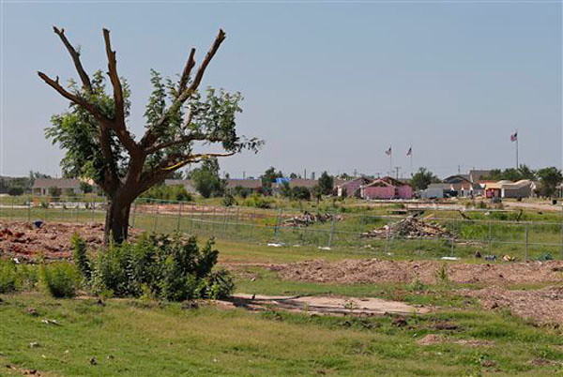**$4362 Received towards Last Year’s $5774**

You know how all tragedy is. In the moment, in the immediate aftermath, we rally with an uncommon strength. We act instinctively in ways that are often beyond our normal means. Friends, family, churches, a whole watching nation focus their compassionate attention on us.

And then, the cameras quit rolling. Friends go home. A nation moves on to the next tragedy. A mudslide in Washington. A shooting in Fort Hood.

Plaza Tower Elementary, Moore, Oklahoma

And yet, broken lives are not yet put back together. They never will be, of course. Especially for those who lost children, or mothers or fathers. Especially for a community that still bears the scars of a not-so-long-ago tragedy.

On May 20, 2013—less than a year ago, Moore, Oklahoma was hit by a massive, F-5 tornado. It was the second one in 14 years. Of all the casualties, the stricken children of Briar Middle school, and Plaza Towers Elementary were the most heart-wrenching.

Workers have cleared the debris there. Twisted metal. Fallen trees. Mangled cars. But the recovery is not yet complete. Through our Outreach Giving, First Christian Church Garland continues to care for the families of Moore, Oklahoma, long after the camera crews have gone home. –Dan

**2014 CHURCH DIRECTORY**

It’s that time again…….yes, *Church Directory time*. Have you ever looked across the aisle and wondered who is that person or ever wanted to send a card and not had a good address? Well now we have a solution! We are developing the 2014 church directory and *will begin shooting photographs for the directory next week, April 7th-12th* starting at 2:15pm during the weekdays and 10am on Saturday. If you would like to reserve a spot for you and your family to have their photographs taken you can go to our website (www.fccgarland.org) and click on the link for the 2014 Directory. There will also be sign-ups in Fellowship Hall this Sunday, April 6th. As always you may contact the church office for assistance. We hope everyone will participate to have a complete directory as it is good to look back on our history.

Bob & Carrie Lee Simpson

and Children

Brenda Crosthwaite, Directory Coordinator



Lenten Services

**Palm Sunday – April 13 9am**

**Maundy Thursday – April 17 7pm**

**Good Friday – April 18 12pm**

**Easter – April 20 9am**

**PRAYERS, JOYS & CONCERNS**

Marty Rogers-cup of life Judi Archibald-The Grapevine

Gary Carroll-Hands of Faith Sheila Patterson-God’s Messengers

We give our sympathy to **Nina Wood** and

family, upon the passing of her borther,

Ray Howdeshell on March 25, 2014

**LENTEN SERMON SERIES CONTINUES**

**Finding Abundant Life:  From Shame to Grace**

The series draws from Dr. Karen McClintock’s book, **Shameless Lives, Grace-full Congregations**. McClintock invites us to become “shame-less,” so we can assist others in the church to find a life of joy and grace. McClintock explores shame as a theological and psychological emotion, defining it as "a feeling of unworthiness in the sight of God or significant others." While guilt says, "I made a mistake," shame says," I am a mistake.” McClintock says that this journey from what she calls the pervasive “shame-reinforced theology of the Church” makes us better able to receive the grace of God and to experience the abundant life that Jesus promises. (John 10:10)

**April 6, 2014 (Session #2)**

**Sermon:**  “Acceptance:  Healing Comparison Shame”

**Scripture:**  Psalm 139:13-16

**April 13, 2014 (Palm Sunday) (Session #3)**

**Sermon:**  “The Problem with Perfectionism:  How Good Do We Have To Be?”

**Scriptures**:  Matthew 5:48; Mark 14:27-31

**HE IS RISEN! SIGNS**

There are four “He Is Risen!” signs for whoever would like to take one home to display in their yard. They are located in Fellowship Hall.

**SNACK SUPPER HELP WANTED**

Every Sunday, youth families take turns providing a meal for the youth who come for youth group.  We currently have a few Sundays open. If you are interested in providing the meal, we usually feed 30-40 youth and adults.  Snack supper does not have to be intricate, but we do ask for a protein, veggie/fruit, and a dessert.  *Available day is 27th*.  Please contact Pastor Allison if you are interested in serving. We currently have partial supplies for nachos and hamburgers if you would like to use.

**PASTOR’S CLASS**

Every year the ministers of the church offer a special class for kids in grades 4 through 8. The class is designed to help youth understand what it means to accept Christ as Lord and become a member of the church through Christian baptism. This year the class is scheduled for **Sunday, April 6th from 4-7:15pm**. Each youth will receive a notebook of information. If your child is in grades 4-8 and has not been baptized please encourage them to attend.  Those who are high school age or older may contact one of the ministers about your desire to be baptized on Easter Sunday, April 20th. Please call the church office (972-272-5423) if your child plans to attend.

**2014 NTA ASSEMBLY**

The annual area assembly will be held at First Christian Church in Plano on May 4th from 3-5pm. The guest preacher is Rev. Coretha Loughridge.

**SENIOR RECOGNITION**

If you have a 2014 high school senior in your family please contact the church office to include them in our senior plans. We will have journals in the Fellowship Hall for members of the congregation to write notes and well wishes. Senior Recognition is scheduled for Sunday, May 18th with a reception to follow for the entire congregation.

**EASTER CANDY DONATIONS**

The Fellowship committee is providing a hotdog lunch on Sunday, April 13th at 11:15am. Following lunch there will be an Easter Egg Hunt. Please invite your family and friends to join in all the fun and fellowship. We need donations of Easter Egg candy in order to have a successful event. There is a box located in Fellowship Hall for all donations.

**CHRISTIAN EDUCATION MINISTRY MEETING**

The Christian Education Ministry has scheduled an information meeting to discuss our 2014 VBS. We invite you to attend. Please come and see what exciting things are planned and the many opportunities available to you. We would love for you to be a part of this amazing children's ministry on

Sunday, April 6, 4:00 PM in room 204.

**LAKE COUNTRY JUBILEE**

The Ruth Mix class will be going to the Lake Country Jubilee on Saturday, May 17th They will meet at the church at 4pm and will take the bus to Terrell. Tickets are $20 each and you need to let Sondra Martin (469.298.3363.) know if you are planning to attend.

**THREE SISTERS FISHING TOURNAMENT**

The Campaign for Disciples Crossing will be holding a fishing tournament on April 12, 2014. Tournament fees are as follows:

$30 per person for an all day fishing pass (9-6pm)

$15 per person to fish for 3 hours (blocks from 9-12, 12-3 and 3-6)

*All Day Pass 9:00 am to 6:00 Registration 8 AM

Canoes - 1st come 1st serve $20 Tournament 9 AM

All fees include lunch.

For more information you may go to 3sistersfishingtourney.com

**COMING THIS SUMMER**

2014 Vacation Bible School June 15th-19th 5pm-8:15pm





**Easter Lily Order Form**

**Name: ________________________________________________________**

**In Memory of : ________________________________________________**

**In honor of: ___________________________________________________**

**Pick up Deliver to a shut-in**

**Easter Lilies are $1700/ per plant. Payment is due at time order is placed.**

**Due by April 14, 2014**

**TOURNAMENT**

**Benefiting**

**For Registration, Rules, & More info: 3sistersfishingtourney.com**