The Messenger
December 5, 2013

HOLIDAY CRAFT FAIR
Our Holiday Craft Fair for Saturday, December 7th has been rescheduled due to inclement weather for the spring of 2014.

CHRISTMAS SEASON
Come, celebrate & experience the Good News of the Christmas Season!

“The life-giving light of Jesus Christ blazes out of the
darkness and the darkness cannot put it out.” John 1:5

Dec 8th 6pm - Christmas Pageant
Dec 15th 9am - Choir Cantata
Dec 24th 6pm & 11pm - Candlelight Service

CHRISTMAS QUILT SALE
The First Christian Church Quilters Club will have a booth at the Craft Fair on December 7th from 9am-3pm. They will also have their annual Christmas Quilt Sale December 8th during coffee fellowship. Come and peruse their crafty creations!

CHRISTMAS MUSICAL
The stage is set in red and green, the Kids Christmas Choir is waiting in the wings, the script is written, and the narrators for this year’s Christmas concert are all set and ready to go – well, all but one. This is the setting for the “For the Glory of the King” a new song and scene musical for Christmas! Join us December 8th at 6pm to watch our creative children bring excitement to the music of Christmas.

CHRISTMAS MUSICAL RECEPTION
As is our custom the adult Sunday School Classes will host a reception following the program. The Theme this year is “Christmas Around the World”. Each class has been assigned a country. Please decorate a table in Fellowship Hall with items from that country and serve foods from recipes from that country. Suggested countries are: Germany-Followers, Mexico-Apostles, Scotland/Norway-Christianity 101, Italy-Cooper, America-Ruth Mix and Crusaders, France-Crossroads.

THIS WEEK’S SERMON
December 8 (Second Sunday in Advent)
Bulletin: PEACE
Sermon: “Cooling the Consuming Fire”
Scripture: Luke 9: 51-56
Synopsis: I’ve watched the Tom Hanks movie, Saving Private Ryan, ten times or more. There are some scenes that are so ghastly, so graphic, that I have to look away. But there’s one scene that transfixes me. On their way to finding Private Ryan, Captain Miller’s men engage in a firefight with German soldiers. When the fight is over, a German soldier is captured. In a rage over how the Germans have killed another one of their platoon, the men circle the captive in blood rage. Probably would have killed him had it not been for Captain Miller’s intervention and call to civility. Maybe, of course, that’s all it ever can be in such circumstances. Civility. Or maybe, there’s another motivation. Another strength and power. Another way. This week’s sermon considers the bitter history between Jews and Greeks and how that history almost erupted in violence. Today, 72 years following Pearl Harbor, 12 years since 9/11, we consider the higher call of God’s peace. (Recommended read: A Higher Call, Adam Makos)

Mark Your Calendar
The 2014 NTA leader event will take place January 25, 2014. The event will take place at Northway Christian Church in Dallas. The theme this year is “Transformation Through Outreach.” The speaker is Johnny Wray, Interim Executive Director for Week of Compassion. More information is on the bulletin board.

CHRISTMAS CANTATA
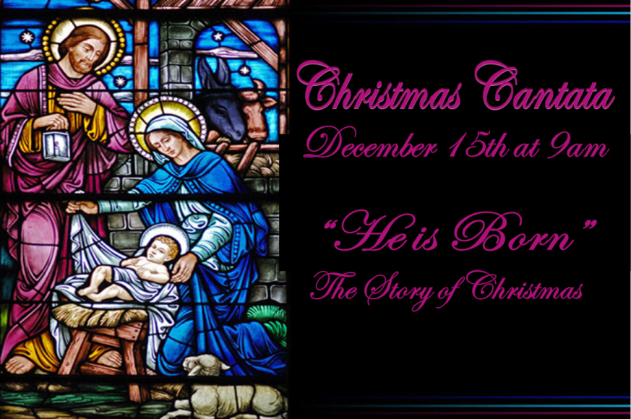

MIKE’S KIDS 2013
(Nov. 2 – Dec. 18)
Mike’s Kid’s is an annual program that is supported by the North Texas Area of Disciples Christian Churches, the Christian Men’s Fellowship, and the Southwest Good Samaritans Ministries. This program supports children and adults who have been abandoned or forced out of their homeland to a new country for political or religious reasons. As the Christmas Season fast approaches it is time to begin filling banana boxes with gently used or new clothing (Appropriate for South Texas) and new underwear, toys (new or gently used), food, etc. for Mike’s Kids in Los Fresnos, Texas.

Many local church groups, youth and others have supported Rev. Feliberto Pereira in
this mission to help the poorest of poor. Over the years Mike’s Kids has sent thousands of boxes full of new or gently used clothes and toys to the Valley. These filled banana boxes brought smiles to many displaced children and families in need. Please consider making Mike’s Kids something your church will share in this year.

Final church collection day will be Sunday, December 15, 2013.
Final pick up of all donations is scheduled for Monday, December 16, 2013 &
Tuesday, December 17, 2013. The truck to Los Fresno, TX will be leaving
Wednesday, December 18, 2013, from Community Christian Church, Richardson.

ADVENT DEVOTIONALS
If you would like an Advent Devotional they are in both the office and Narthex. This year’s Devotionals are published by Austin Presbyterian Theological Seminary, Dan’s doctoral alma mater.

ANGEL TREE
If you picked up an angel from our tree in Fellowship Hall please be sure to have all the gifts to the church Sunday, December 8th by 11am. We will then take all the gifts to the First Christian Church in Rowlett, TX.

If you are unable to have your gifts delivered to the church by the designated time please contact Sharon Campbell at 214.557.2086.

It has been my pleasure to have chaired the Outreach Ministry for 2013. Our ministry has been very successful this year due to your continued support.

Sharon Campbell

Poinesettia Order
Due Date: December 16th, 2013
Cost: $17.00

Sponsor: ______________________________________________________

In Honor of: __________________________________________________

In Memory of: ________________________________________________

Deliver to Shut in ____
Pick up after Christmas Day Service ____

