The Messenger

October 17, 2013

ALL CHURCH WORKDAY BEGINS WITH BREAKFAST AT 8AM

There will be a church workday October 19th at 9am. The cleaning will start at the front door of our church and continue through to the back of the church. Cleaning will be concentrated on the sanctuary. We will continue the work day on February 8th at 9am. There is a box under the stairs for empty spray bottles. All donations can be placed in this box. If you have any questions please feel free to contact Brenda Crosthwaite 972.495.3681. There will be a Men’s Breakfast Saturday morning at 8 A.M. You are invited to come and enjoy the food and fellowship before you start the work on the church.



**First Christian Church Fall Festival, October 27th**

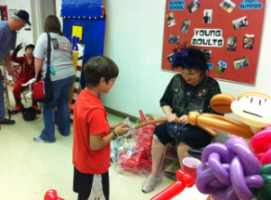**This year’s Fall Festival promises to be one of our best. Not only are we having NEW games but there will also be a costume contest and yummy chili cook-off. A sign-up sheet for the chili cook-off is located in fellowship hall. Our youth groups are accepting donations of the following: Candy, Cakes and Baked Goods, Bingo Prizes (Gift Certificates, gift sets, movie passes.). Thank you for all of your support! Your donations help us fund our mission trip each year.**

**HOLIDAY CRAFT FAIR**

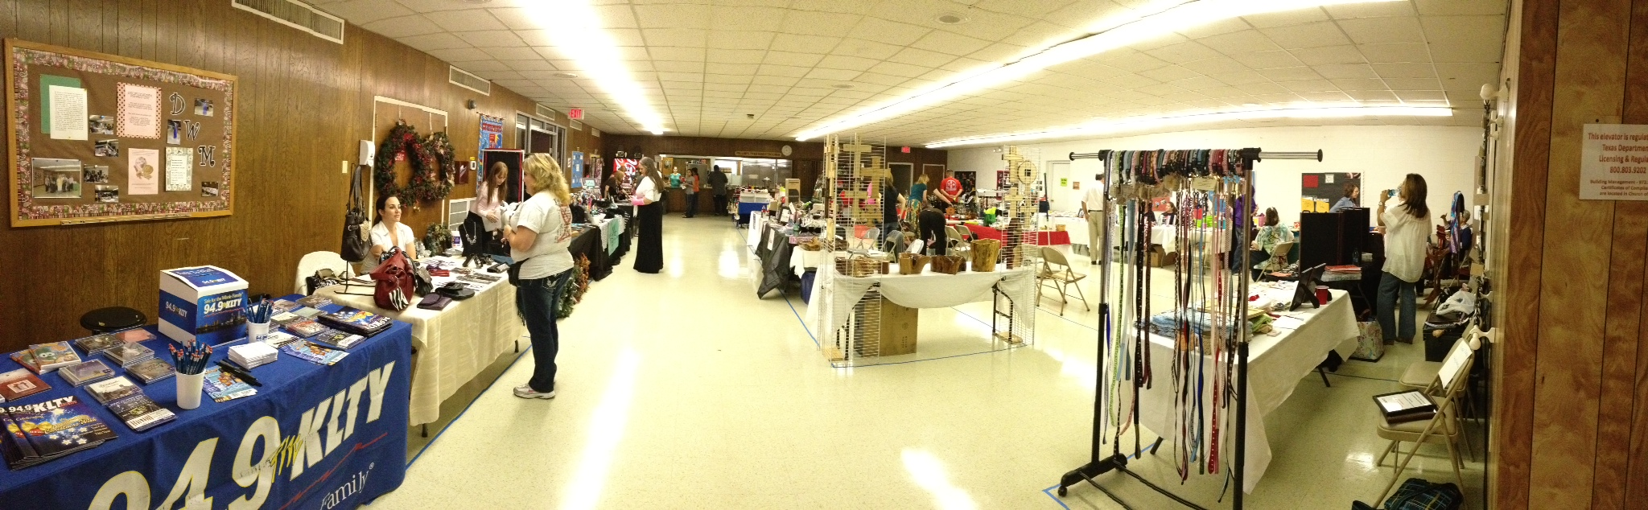

It’s time to start thinking about our Holiday Craft Fair! On *Saturday, December 7th* from 9am-3pm, we will have multiple vendors selling their crafts and products. So far, we have Avon, Scentsy, handmade jewelry, baby quilts, and more! If you are interested in being a vendor or know someone who is interested, contact Rev. Allison Ray.

**THIS WEEK’S SERMON**

**October 20, 2013 (Children’s Sabbath Sunday)**

**Sermon:**  “Helping Timothy”

**Scripture**:  2 Timothy 1:1-7

**Synopsis:**  The gracious tone of Paul’s letter to Timothy speaks as deeply to me as any instruction Paul gives.  In my life it has ever been so:  In relationship with others in the church I tend to hear not so much what people say to me as how they say what they say.  The situation is obvious in this week’s passage.  Young Timothy is struggling as a young minister with the challenges of life in the Church.  Paul, the minister emeritus, has been there, done that; has seen it all.  No doubt, Timothy has made some mistakes.  Paul’s first letter to Timothy seems to be written for the purpose of correcting some doctrinal miscalculations.  But here, in his second letter, the tone is markedly different. Here Paul writes not to scold, correct, teach or reprimand.  Rather he seems determined to encourage, edify and lift up.  It strikes me that in the church, our church, we make a great deal about having nurtured many Timothies—youth who have grown up to receive the call to ministry.  It’s a good thing about our church that we have the gifts to nurture such calls.  Yet, Paul’s gracious, encouraging, letter to young Timothy reminds me that our role as mentors, teachers and encouragers doesn’t end at inception.  The Church, our church, waits with great expectation for a new generation of leadership to emerge.  Maybe we hasten their emergence by doing everything in our power to believe the best in them, help them, encourage them.

**Scripture Link**: <http://bible.oremus.org/?ql=247062252>



**Youth Activities for Sunday, October 20th**

 4:00pm Children’s Choir

5:00pm The Gathering

5:30pm Snack Supper

6:00pm Youth Activities

Youth Bible Study 6pm on Wednesday nights

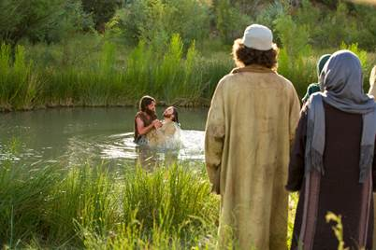**GOSPEL STUDY**

Sunday Evenings 6 p.m. in the Cole Parlor

Using George W. Knight’s book, **A Simplified Harmony of the Gospels,** we will begin a new chapter in Jesus’ life, “Preparation for the Beginning of Jesus’ Ministry.”  This Sunday evening we’ll look at what the gospels say about John the Baptizer’s preaching and baptizing, Jesus’ baptism and following temptation, the Baptizer’s acknowledgement of Jesus as Messiah, and Jesus’ first call of disciples.

ALL SAINTS SUNDAY

On November 3rd during the 9am worship service we will remember those members who have passed away this past year. Their names will be spoken and a candle lit in celebration of their lives.

**CHI RHO FALL RALLY**

November 3, 2013 from 2-5pm at Creekwood Christian Church located at 2660 Forest Vista Dr. in Flower Mound, TX

Tour to the George W. Bush Presidential Library and Museum

There will be a First Christian Church Group Tour to the George W. Bush Presidential Library and Museum on November 18, 2013. We will meet at FCCG at 9:30am to ride on the bus. There are four slots available if you want to ride on the bus.

Cost: $3 for bus

$9 for seniors (61 & older)

$10 for adults

$9 youth (13-17)

$6 youth (5-12)

We will have lunch at Café 43 located at the museum. Cost is $7 and $12. If you plan to attend please give museum money to Sondra Martin by October 7th and place your name in one of the open slots on the sheet on the bulletin board.

**NTA Adult Mission Trip**

Our NTA Outreach Chair, Debby Bobbitt, has arranged an Adult Mission Trip to Joplin, MO in December.  A flyer is on our bulletin board.  The cost is $75 which includes a $25 non-refundable deposit.  Accommodations are at the South Joplin Christian Church – bunk beds so bring sleeping bags or bedding.  Showers are at the church mission station.  There are also kitchen facilities with utensils and cookware and access to a laundry.  You arrive on Sunday, work Monday – Friday and leave on Saturday.  This is through the Disciples Volunteering office.  20 people are needed for the trip.

Debby is in charge of reservations and arrangements so if you have questions please contact her at [oldm0m@yahoo.com](mailto:oldm0m@yahoo.com) or you may call her at 214.282.1914.

**NOMINATIONS FOR THE 2014 BOARD**

Attached you will find a nomination form to nominate perspective candidates for the 2014 Board. Please return the forms in a sealed envelope marked attention: Nominating Committee.

**NOMINATING COMMITTEE ACCEPTING NOMINATIONS FOR**

**2014 ELDER, TRUSTEE, DEACON AND JUNIOR DEACON**

Nominations can be made by completing the form below and returning it to the church office or to a member of the nominating committee on or before October 27, 2013.

Nominating Committee:

Judy Grasham - Chair Tammy Holcomb

Carol White Dancey Caldwell

Amber McMillan Kim Whalin

David Worden Leasa Wolf

PLEASE RETURN IN A SEALED ENVELOPE MARKED:

ATTENTION: NOMINATING COMMITTEE

**Nomination for Officer**

I suggest the name of ___________________________________for nomination to the General Board for:

(_____)Elder (_____) Trustee (_____) Deacon (_____) Jr. Deacon (9th – 11th grade)

To help the Committee evaluate this person’s qualifications, please comment on the candidate in such areas as the following:

General Membership – attendance in public worship, participation in church activities, offices held, services rendered.

Christian Living in Daily Life - within the family, at work, in the community.

Personal Characteristics and Skills – cooperativeness, willingness to learn, ability to follow through on assignments, openness to new ideas, maturity of judgment.

Comments: ___________________________________________________ ______________________________________________________________ ___________________________________________________________________ _________________________________________________________________ _______________

___________________________________________________________________ _________________________________________________________________ _______________

___________________________________________________________________ _________________________________________________________________ _______________

Signature Date ___ _