Messenger Lite

October 10, 2013



**First Christian Church Fall Festival, October 27th**

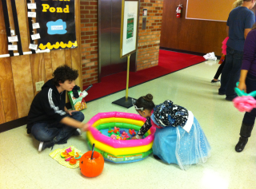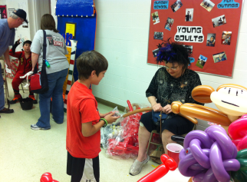**This year’s Fall Festival promises to be one of our best. Not only are we having NEW games but there will also be a costume contest and yummy chili cook-off. A sign up sheet for the chili cook-off is located in fellowship hall. Our youth groups are accepting donations of the following: Candy, Cakes and Baked Goods, Bingo Prizes (Gift Certificates, gift sets, movie passes.). Thank you for all of your support! Your donations help us fund our mission trip each year.**

**HOLIDAY CRAFT FAIR**

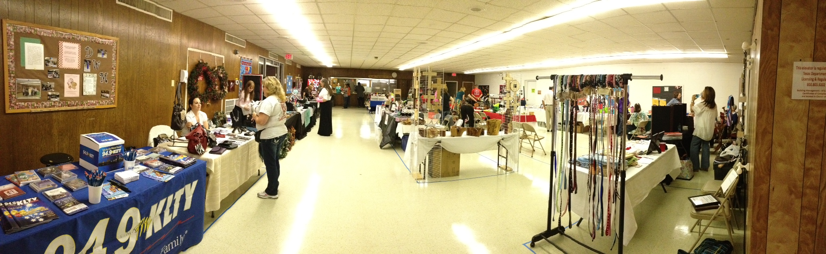

It’s time to start thinking about our Holiday Craft Fair! On *Saturday, December 7th* from 9am-3pm, we will have multiple vendors selling their crafts and products. So far, we have Avon, Scentsy, handmade jewelry, baby quilts, and more! If you are interested in being a vendor or know someone who is interested, contact Rev. Allison Ray.

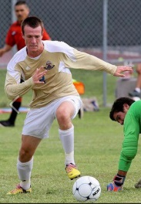

**IN THE LIFE…**

One of our young adults, Jack Wolf is playing a soccer game at Dallas Baptist University on Oct 19th at 5pm.  Jack is currently a sophomore at St. Mary’s University in San Antonio, TX.  Dallas Baptist University is located at 3000 Mountain Creek Pkwy, Dallas, TX 75211.  We hope to see you there!

**THIS WEEK’S SERMON**

**October 13, 2013**

**Sermon:**  “Put In A Good Word”

**Scripture:**  Acts 9:26-31

**Synopsis:**  The Scriptures repeatedly reminds us that part of practicing Christian ethics is developing the discipline to refrain from saying words that damage.  The writer of James, for instance, emphasizes the great need to “bridle” one’s tongue.  And Paul?  In his second letter to Timothy, Paul talks about the need to “avoid profane chatter.”  In 1 Peter, the writer warns about “keeping one’s tongue from evil and one’s lips from speaking deceit.”  And we should pay attention to all these things.  As the saying goes, “If you don’t have anything good to say, then don’t say anything.” But that’s only part of the challenge of Christian ethics.  The other part, insofar as our speech is concerned, is thinking of creative ways, disciplining ourselves, to use our words as opportunities to say good things, encouraging things, edifying things about others.  This week, I’m inspired by a Christian named Barnabas.  His ability to say a good word for a struggling disciple trying to get his feet made a huge difference.   What great gifts of the Spirit might emerge in our midst if we learned to speak well of others?

WE NEED YOU!

We will be holding our one and only blood drive on October 13th. The Outreach ministry would like this drive to be successful. Please be aware you may only donate every 60 days.

**Youth Activities for Sunday, October 13th**

 4:00pm Children’s Choir

5:00pm The Gathering

5:30pm Snack Supper

6:00pm Youth Activities

Youth Bible Study 6pm on Wednesday nights

**Eagle Court of Honor**

We would like to congratulate Kayne Alan Harrison on becoming an Eagle Scout. Kayne has completed the required number of merit badges for this prestigious honor. Kayne belongs to Troop 57, Circle Ten Council Boy Scouts of America. His parents are Kevin & Jana Harrison and grandparents are Mike & Jeri Harrison.

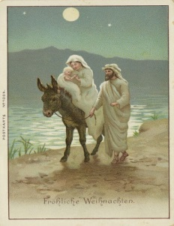

**Gospel Study**

Sunday Evenings 6 p.m. in the Cole Parlor

Using George W. Knight’s book, **A Simplified Harmony of the Gospels,** we will continue our study of the birth and childhood of Jesus, beginning with Matthew’s account of Joseph’s dream, the Holy Family’s flight to Egypt (Matthew 2:13-15), and their return.

MEN’S BREAKFAST

There will be a Men’s Breakfast Saturday, (10/19) at 8 A.M. I hope all of you will come and enjoy the food and fellowship.

CHURCH WORKDAY

There will be a church workday October 19th at 9am. The cleaning will start at the front door of our church and continue through to the back of the church. Cleaning will be concentrated on the sanctuary. We will continue the work day on February 8th at 9am. There is a box under the stairs for empty spray bottles. All donations can be placed in this box. If you have any questions please feel free to contact Brenda Crosthwaite 972.495.3681.

Tour to the George W. Bush Presidential Library and Museum

There will be a First Christian Church Group Tour to the George W. Bush Presidential Library and Museum on October 21, 2013. We will meet at FCCG at 9am to ride on the bus. There are four slots available if you want to ride on the bus.

Cost: $3 for bus

$9 for seniors (61 & older)

$10 for adults

$9 youth (13-17)

$6 youth (5-12)

We will have lunch at Café 43 located at the museum. Cost is $7 and $12. If you plan to attend please give museum money to Sondra Martin by October 7th and place your name in one of the open slots on the sheet on the bulletin board.

**NTA Adult Mission Trip**

Our NTA Outreach Chair, Debby Bobbitt, has arranged an Adult Mission Trip to Joplin, MO in December.  A flyer is on our bulletin board.  The cost is $75 which includes a $25 non-refundable deposit.  Accommodations are at the South Joplin Christian Church – bunk beds so bring sleeping bags or bedding.  Showers are at the church mission station.  There are also kitchen facilities with utensils and cookware and access to a laundry.  You arrive on Sunday, work Monday – Friday and leave on Saturday.  This is through the Disciples Volunteering office.  20 people are needed for the trip.

Debby is in charge of reservations and arrangements so if you have questions please contact her at [oldm0m@yahoo.com](mailto:oldm0m@yahoo.com) or you may call her at 214.282.1914.

**CHI RHO FALL RALLY**

November 3, 2013 from 2-5pm at Creekwood Christian Church located at 2660 Forest Vista Dr. in Flower Mound, TX

**NOMINATIONS FOR THE 2014 BOARD**

Attached you will find a nomination form to nominate perspective candidates for the 2014 Board. Please return the forms in a sealed envelope marked attention: Nominating Committee.

**NOMINATING COMMITTEE ACCEPTING NOMINATIONS FOR**

**2014 ELDER, TRUSTEE, DEACON AND JUNIOR DEACON**

Nominations can be made by completing the form below and returning it to the church office or to a member of the nominating committee on or before October 27, 2013.

Nominating Committee:

Judy Grasham - Chair Tammy Holcomb

Carol White Dancey Caldwell

Amber McMillan Kim Whalin

David Worden Leasa Wolf

PLEASE RETURN IN A SEALED ENVELOPE MARKED:

ATTENTION: NOMINATING COMMITTEE

**Nomination for Officer**

I suggest the name of ___________________________________for nomination to the General Board for:

(_____)Elder (_____) Trustee (_____) Deacon (_____) Jr. Deacon (9th – 11th grade)

To help the Committee evaluate this person’s qualifications, please comment on the candidate in such areas as the following:

General Membership – attendance in public worship, participation in church activities, offices held, services rendered.

Christian Living in Daily Life - within the family, at work, in the community.

Personal Characteristics and Skills – cooperativeness, willingness to learn, ability to follow through on assignments, openness to new ideas, maturity of judgment.

Comments: ___________________________________________________ ______________________________________________________________ ___________________________________________________________________ _________________________________________________________________ _______________

___________________________________________________________________ _________________________________________________________________ _______________

___________________________________________________________________ _________________________________________________________________ _______________

Signature Date ___ _