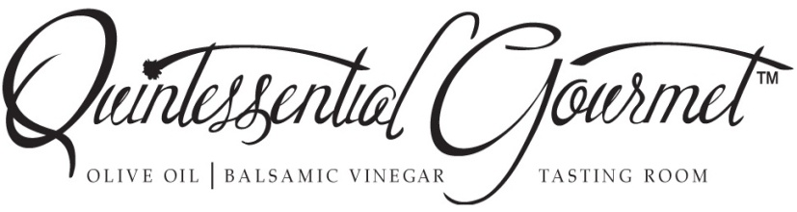
Rocket (Arugula) Pasta

Serves 4 sides or 2 entrée
½ pound uncooked Lemon Pepper pasta
(I use gluten free lemon pepper pasta but any plain cut pasta will do)
1 cup Lemon Olive Oil
1 Tablespoon Garlic minced
1 cup chopped Prosciutto
5 or 6 grinds of black pepper
3 cups Arugula course chopped 2 ½ cups in pasta, ½ cup for garnish
½ cup grated parmesan
Cook pasta according to package directions, drain reserving ½ cup of the pasta water.
Sauté prosciutto, garlic, and pepper in 1/2 cup lemon olive oil until barely brown, turn off heat let cool a bit. Toss all ingredients in a bowl add remaining ½ cup lemon olive oil and garnish with ½ chopped Arugula.

Note: this dish can be served year round hot or cold.
For Lunch add a mixed green salad and bread.
For dinner serve as a side dish.

