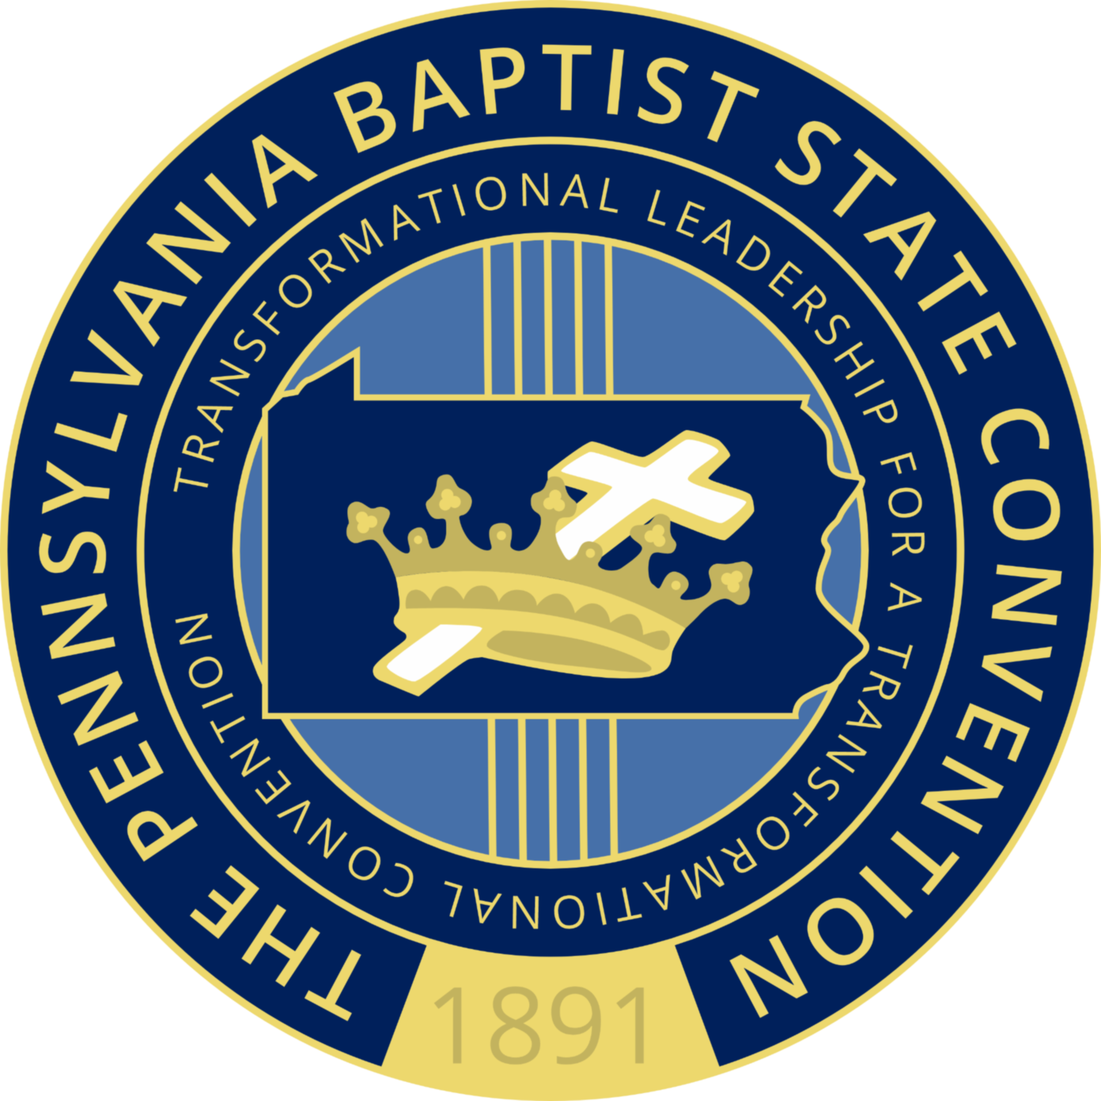

PENNSYLVANIA BAPTIST STATE CONVENTION 128th ANNUAL SESSION
MONDAY, OCTOBER 14, 2019
2:00 PM Executive Committee Meeting

3:00 PM Registration

3:00 PM Board Meeting

Vice President at Large - Dr. Alec K. Piper, Presiding
(Agenda on separate sheet)

4:00PM Memorial Sermon –– Rev. Douglass Wright, Pastor
Mt. Lebanon Baptist Church, Brownsville, PA

Convention Offering

5:00PM D I N N E R

Evening Session

Regional Vice President (Southwest) — Dr. Delonte Reeves, Presiding

7:00PM Welcome Program

Youghiogheny Western Baptist Association — Rev. Vincent L. Winfrey, Sr., Moderator

10:00PM L A T E N I G H T W O R S H I P
Rev. Richard Hampton, Chairman

PENNSYLVANIA BAPTIST STATE CONVENTION 128th ANNUAL SESSION
TUESDAY, OCTOBER 15, 2019
Morning Session
Regional Vice President (Southwest) - Dr. Delonte Reeves, Sr., Presiding

9:00AM Registration
9:15AM Praise & Worship — Rev. Andrew Tribble
9:30AM Official Opening of 128th Annual Session
Dr. Bruce N. Alick, President

Scripture Reading: Romans 12:1-2 — Minister Natalie Winfrey
Prayer for Our Convention — Rev. Marvin Harris
Prayer for Our Country — Rev. Marvin Wright
Prayer for Our Churches — Rev. Andrew Dent

9:45 — 10:45AM Convention Lecturer - Dr. Harold Dean Trulear
“Creating a Church Culture for Correctional Ministry”

10:45AM Appointment of Committees

11:00AM Opening Sermon – Rev. Clifford A. Carter, Former President
Pennsylvania Baptist State Convention, Inc.

Convention Offering
Announcements

12:00PM L U N C H

PENNSYLVANIA BAPTIST STATE CONVENTION 128th ANNUAL SESSION
TUESDAY OCTOBER 15, 2019
12:30 — 3:00PM Women/Minister’s Spouses, Widows, and Widowers Luncheon

Afternoon Session

Regional Vice President (Southwest) - Rev. Dr. Delonte Reeves, Sr., Presiding

1:00 — 2:00PM Nurses/Ushers Ministries
Sister Marian Elby, Nurse’s President
Sister Dorothy Brown, Usher’s President

2:15 – 3:15PM Laymen’s Ministry
Deacon Matthew Smith, Laymen’s President
3:30 — 4:45PM Ministry Meetings
D I N N E R

Regional Vice President (Southwest) - Rev. Dr. Delonte Reeves, Sr., Presiding

7:00PM Convention at Worship
Praise and Worship — Rev. Andrew Tribble
Prayer
Scripture Reading: Romans 12:1-2
Selection
Convention Offering
Introduction of Preacher / Selection
Sermon: Rev. Marvin Harris, Pastor
Mt. Calvary Baptist Church, Fairchance, PA

10:00PM L A T E N I G H T W O R S H I P
Rev. Richard Hampton, Chairman

PENNSYLVANIA BAPTIST STATE CONVENTION 128th ANNUAL SESSION
WEDNESDAY OCTOBER 16, 2019
Morning Session

Regional Vice President (Central) – Rev. Dr. Arthur Brown, Presiding

9:00AM Registration

9:15AM Praise & Worship — Rev. Andrew Tribble

9:30 — 10:30AM Convention Lecturer - Dr. Harold Dean Trulear
“Family Matters: Ministering to those Left Behind”

10:00 — 10:30AM Special Presentation — Dennis Brown
“Caring for the Shepherd and the Sheep”

10:30 — 11:00AM Special Presentation — Dr. Wayne Weathers, Chairman
Political Action/Social Justice Ministry

11:00AM Clergy Hour

Rev. Dr. F. Diane Hobson - Clergy President
Pastor, Mt. Sinai Baptist Church, Charleroi, PA

Convention Offering

Announcements

12:00PM L U N C H

PENNSYLVANIA BAPTIST STATE CONVENTION 128th ANNUAL SESSION
WEDNESDAY OCTOBER 16, 2019
Afternoon Session

Regional Vice President (Central) Rev. Dr. Arthur Brown, Presiding

1:30 — 2:45PM . Women’s Ministry
Sister Patricia White, President

3:00 — 4:00PM Minister’s Spouses, Widows, and Widowers Ministry
Sister Johnella Munnerlyn, President

4:00 — 5:00PM Regional Meetings

D I N N E R

6:30PM President’s Banquet
(Program Under Separate Cover)

10:00PM L A T E N I G H T WO R S H I P
Rev. Richard Hampton, Chairman

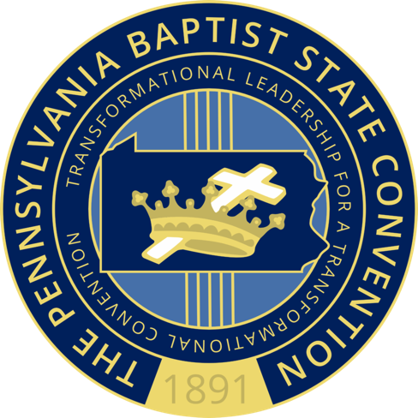
PENNSYLVANIA BAPTIST STATE CONVENTION 128th ANNUAL SESSION
THURSDAY OCTOBER 17, 2019
Morning Session

Regional Vice President (East) - Rev. Dr. Raymond Merriweather, Presiding

9:00AM Registration

9:15AM Praise & Worship — Rev. Andrew Tribble

9:30AM — 10:45AM Convention Lecture – Rev. Dr. Harold Dean Trulear
“The Lock and Keystone State: What Needs to be Fixed and How to Do It”

11:00 — 12:00PM Morning Sermon – Rev. William C. Calloway, Pastor
Mt. Olive First Baptist Church, Clairton, PA

Convention Offering

Announcements

12:00PM L U N C H

PENNSYLVANIA BAPTIST STATE CONVENTION 128th ANNUAL SESSION
THURSDAY OCTOBER 17, 2019
Afternoon Session

1:30PM Praise & Worship — Rev. Andrew Tribble

1:45PM Denominational Reports

National Baptist Convention, USA, Inc.
Progressive National Baptist Convention, Inc.
Southern Baptist Convention
Lott Carey

2:15PM Convention Business Meeting

Ministry Reports
Time & Place Report – Rev. Alec K. Piper, VPAL
Nominating Committee Report – Dr. Arthur White

Announcements

D I N N E R

7:00PM President’s Hour
(Program Under Separate Cover)

PENNSYLVANIA BAPTIST STATE CONVENTION 128th ANNUAL SESSION
FRIDAY OCTOBER 18, 2019
Regional Vice President (West) — Rev. Dr. Richard Wingfield, Presiding

9:00AM Praise & Worship — Rev. Andrew Tribble

9:30AM Logistics Report – Kim Fleming

A. Mid Winter Board Meeting – 2020
B. Calendar for 2020

Registration Report

Financial Report

11:00AM Closing Sermon - Rev. Vincent L. Winfrey, Pastor
Mt. Olive Baptist Church, Uniontown, PA

12:00PM Parting Handshake - “God Be With You”

Benediction

Session Adjourned

**** Note: Changes may occur as needed*****

