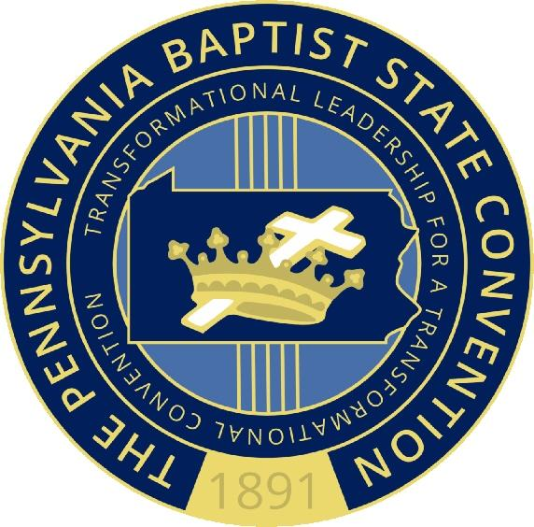Pennsylvania Baptist State Convention

WOMEN’S MINISTRY
  - Servant Patricia A. White - President

Annual Spiritual Women’s Retreat
June 21 & 22, 2019

Eden Resort & Suites - 222 Eden Road, Lancaster, PA 17601
The
Friday, June 21, 2019  Registration 9:00 AM – 12 noon  American Lunch Buffet 12:30 PM  Opening Session – 2:00 PM  Hotel Check-In at 4:00 PM  Grand Dinner Buffet at 5:30 PM | Saturday, June 22, 2019  Early Bird Breakfast Buffet  American Lunch Buffet | Package includes:  One (1) night’s lodging  Early Bird Breakfast Buffet  (2) American Lunch Buffets  (1) Dinner Buffet  Retreat Packet
me: “Plug Into the Power” Acts
Cost Per Person:
Single: $365.00 Double: $250.00 each Triple: $215.00 each Quad: $198.00 each
Deposit (non-refundable) $50.00 per person

Final Payment Due: Friday, May 17, 2019
Make checks payable to: PBSC Women’s Ministry

Mail To: Servant Minnie G. Green, 1119 E. Poplar St., York, PA 17403
Telephone: 717-852-0837 (Hm)/ 843-560-6524 (Cell)

REGISTRATION Deadline Monday, April 15, 2019

NAME ________________________________________________________________________________
Address:_______________________________________________________________________________
Phone: ________________________________
Email: _______________________________________
Church: ___________________________________________________________

Roommates:

______________________________________________________________________________________

______________________________________________________ Amount Enclosed: $___________

Register Early!!!

Servant Minnie G. Green, Chair Servant Karen Williams, Co-Chair

