PENNSYLVANIA BAPTIST CONVENTION
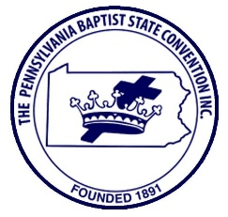

Office of the President
Dr. Bruce Alick

Pennsylvania Baptist State Convention (PBSC) Vendor Information & Application

The Pennsylvania Baptist State Convention's (PBSC) Annual Session will be held at the
Renaissance Philadelphia Airport Hotel, 500 Stevens Drive, Philadelphia, PA 19113; from Wednesday, April 24 through Friday, April 26, 2019. Set up time is 9:00 am on April 24th and closing time is 12:00 Noon on Friday, April 26th. Rev. Dr. Raymond Merriweather is the Host Pastor. There will be approximately 150 to 200 persons attending this Mid-Year Session.

PBSC’s exhibit area will be a marketplace of biblical supplies & books, wearing apparel, other organizations, agencies, colleges and seminaries who will showcase their information and merchandise for our participants. If you wish to be an Exhibitor or a Vendor, the amount is $100.00. Fill out the form below and send along with a cashier’s check or money order made out to the Pennsylvania Baptist State Convention, and send to
_________________________________________.

Name______________________________________________ Date_____________________________

Address______________________________________________________________________________

City______________________________________________ State___________ Zip Code____________

Telephone No._______________________________ Fax No.___________________________________

Cell No. ________________________________ Email Address_________________________________

Type of Products_______________________________________________________________________

Signature_____________________________________________________________________________

Exhibitor Move-In Date/Hours: Wednesday, April 24th at 9:00 am and
Move-Out date is Friday, April 26th at 12:00 Noon.

For Official Use Only: Date check/money order received___________________

Date receipt sent_________________

