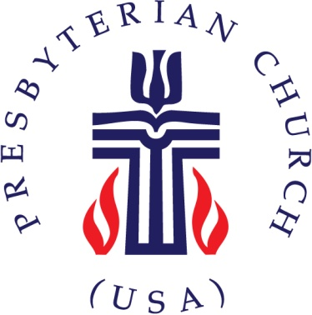
Activity Permission
& Liability Waiver Form

I consent to the participation of my child(ren) for Vacation Bible School on June 22 – June 25, 2015 at 5:30 pm-8:30 pm as arranged by Christian Community Presbyterian Church

I/we hereby release Christian Community Presbyterian Church located at 3120 Belair Drive Bowie, Md 20715, its employees and all official representatives of the church from any liability to the extent permitted by law.

Parent or Guardian Signature Date

Printed Name(S) Phone Number

Address

Parent or Guardian Email

Child’s grade in fall 2015

