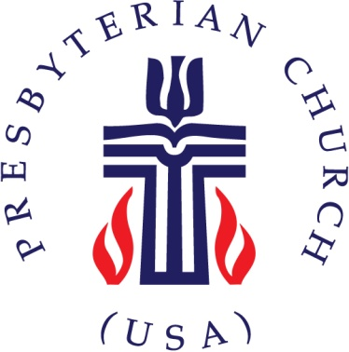
Activity Permission
& Liability Waiver Form

I consent to the participation of my child(ren) for Vacation Bible School on June 20 – June 23, 2016 at 6 pm-8:30 pm as arranged by Christian Community Presbyterian Church.

I/we hereby release Christian Community Presbyterian Church located at 3120 Belair Drive Bowie, Md 20715, its employees and all official representatives of the church from any liability to the extent permitted by law.

Parent or Guardian Signature Date

Printed Name(S) Phone Number

Address

Parent or Guardian Email

Child’s grade in fall 2016

Participant
Information Form
To be completed & signed by parents of all students under age 18
Valid May 15, 2016-May 15, 2017

Child’s Name
Date of birth Height Weight
Insurance Provider Policy #
Doctor’s Name Phone #
Medicines taking and dosages
Allergies to food or drugs
Chronic or recurring illnesses
Handicaps or other limitations
Any other medical concerns CCPC should be aware of ________
Parent/Guardian’s Name Phone #
Cell Phone # Work #
Address
Emergency contact if parent can’t be reached:
Phone # Relationship:
Address
Parent/Guardian Permission for Care & Treatment of Minor or Dependent Adult
As parent(s)/guardian(s) of , I/we hereby grant permission and empower the staff of Christian Community Presbyterian Church, its pastors, lay staff, counselors, volunteers, and/or agents, to make any necessary decisions involving the above said child, youth or dependent in case of emergency. In no event will the congregation, the Presbytery or the PCUSA, its pastors, staff, counselors, advisors, and/or agents be held liable for any first-aid rendered, treatment, drugs, medicine, or surgical procedures performed pursuant to this consent. I agree to pay for any expenses incurred for any action to obtain medical treatment. In the event of emergency, every effort will be made to contact the parent(s)/guardian(s) before any medical services may be rendered, aside from the administration of general first-aid. Copies of this form made by the staff of Christian Community Presbyterian Church will be considered as an original giving my permission for attending physician(s) and other medical personnel to administer any needed medical treatment.
Publicity Release and Consent
Staff and adult volunteers at Christian Community Presbyterian Church often take photographs or make video or sound recordings of children and adults involved in church activities. It is our practice never to publish names with images of minors.
I consent to the use of any such audio or visual record of the child named above or me, if I am participating, to be used by agents of the church for church publications or on the church website or social networking sites. Initial.
Release of Liability
By signing this Participant and Medical Information and Consent Form, I expressly warrant that I am (if I am a participant) or the minor named above is capable of withstanding both the physical and mental demands of routine church activities and those for which I give special permission (off-site or overnights).
I also expressly assume all risks of the child or me participating in the activities, whether such risks are known or unknown to me at this time. I further release Christian Community Presbyterian Church and its ministers, leaders, employees, volunteers, and agents from any claim that my child may have or that I may have against them as a result of injury or illness incurred during the course of participation in the church activities and programs. This release of liability shall include (without limitation) any claims of negligence or breach of warranty. This release of liability is also intended to cover all claims that members of the child’s or my family or estate, heirs, representatives, or assignees may have against Christian Community Presbyterian Church or its ministers, leaders, employees, volunteers, or agents.
Furthermore, I understand that if my child violates the rules that he or she may be SENT HOME AT THE EXPENSE of PARENT (S) OR GUARDIAN (S). All money invested in the activity will be forfeited. Initial.

This Medical and Emergency Contact Information and Publicity Authorization
will be in effect May 15, 2016-May 15, 2017. It is my responsibility to update this form if my child’s health history changes.

Signature: Date:
Name Printed:

